

|  |  |
| --- | --- |
| **Intake: APD1F2409CS(CYB)** | **Module Code: CT044-3-1-IOOP** |

|  |  |  |
| --- | --- | --- |
| **HAND OUT DATE: Wednesday, 16 April 2025 Week 5** |  |  |
| **SUBMISSION DATE: Saturday, 14 June 2025 Week 12** |  |  |

**TITLE:**

**SedapMakan Management System**

**Module Lecturer: Ms. Mary Ting**

**GROUP NAME S**

|  |  |
| --- | --- |
| **AHMED MIRAHUSAIN ALVI** | **TP084807** |
| **BADR MAHDI MUBARAK AL-AMRI** | **TP083084** |
| **MOHAMED ABA SAID** | **TP082376** |
| **AHAMAD MUHAMAD MUSTHAFA** | **TP085194** |

TABLE OF CONTENTS

CHAPTER 1: INTRODUCTION 1

CHAPTER 2: STORYBOARD 2

2.1 System Admin 2

2.1.1 Dashboard form 2

2.1.2 Profile form 3

2.1.3 Manage Users form 5

2.1.4 E-Wallet Report form 6

2.1.5 Sales Report form 8

2.2 Manager 10

2.2.1 Dashboard form 10

2.2.2 Profile form 13

2.2.3 View & Respond Feedback form 15

2.2.4 E-Wallet Top-up form 17

2.2.5 Refund Approval form 19

2.3 Chef 21

2.3.1 Dashboard form 21

2.3.1 Profile form 23

2.3.4 Order List form 27

2.4 Customer 29

2.4.1 Dashboard form 29

2.4.2 Profile form 31

2.4.3 Menu form 35

2.4.4 Orders form 39

2.4.5 E-Wallet Form 41

2.4.6 Feedback form 45

CHAPTER 3: USE-CASE DIAGRAM 48

CHAPTER 4: CLASS DIAGRAM 50

CHAPTER 5: EXPLANATION OF CODES & METHODS IMPLEMENTED 51

5.1 System Admin 51

5.2 Manager 52

**1.1.1** **1. Manager manager = new Manager();** 59

**1.1.2** **2. Form form = new FormName(userId);** 60

**1.1.3** **3. DataTable dt = manager.GetPendingRefunds();** 61

**1.1.4** **4. SqlCommand, SqlConnection, SqlDataAdapter** 61

5.3 Chef 62

5.3.1 Class Explanation: The Chef Class 62

5.3.2 Methods Explanation: 62

5.3.3 Objects Explanation: 68

5.4 Customer 73

CHAPTER 6: TEST PLAN & TEST CASES 86

REFERENCES 91

WORKLOAD MATRIX 92

CHAPTER 1: INTRODUCTION

The Seedap Makan management system is a standalone, database-driven application developed to manage the operations of Seedap Makan, a modern restaurant located in Bukit Jalil. Designed to streamline the ordering process and internal restaurant management, the system integrates various functions for different user roles within a single software platform.

The system supports four main roles: system administrator, manager, chef, and customer. Each role has specific access rights and responsibilities to ensure workflow efficiency and data integrity. The system administrator is responsible for user management, sales, and e-wallet reporting. The manager is responsible for processing customer feedback, approving refunds, and assisting with e-wallet top-ups. Four dedicated chefs are responsible for managing dishes in a specific category: vegetarian, Italian, Mexican, and drinks. Customers interact with the system by browsing the menu, placing orders, managing their e-wallet, tracking their orders, and submitting feedback or refund requests.

For ease of use, the system incorporates a login feature that redirects users to their dashboards based on their role. This system ensures secure, role-specific access while maintaining a smooth and user-friendly interface. This application uses C# with graphical user interface components and a SQL database for persistent data storage. Fundamental object-oriented programming concepts, such as classes, methods, and objects, are applied throughout the system development process to improve modifiability, extensibility, and maintainability.

This report describes the design, development, testing, and evaluation of the SedapMakan management system, in accordance with the course learning objectives. It includes visual diagrams, explanations of key code snippets, test cases, and a critical analysis of the finalized system. (Sander Rossel, 2014)

CHAPTER 2: STORYBOARD

2.1 System Admin

2.1.1 Dashboard form

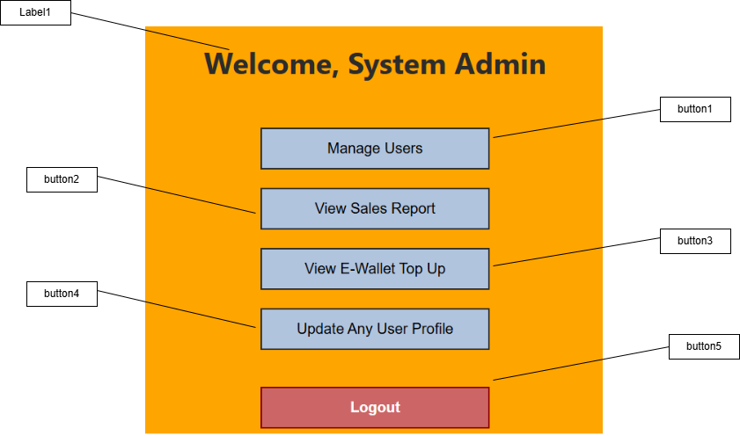

|  |  |  |
| --- | --- | --- |
| Control | Control Name | Description |
| Lable1 | lblAdminWelcome | Displays a welcome message to the system admin. |
| Button1 | btnManageUsers | Opens the user management interface. |
| Button2 | btnSalesReport | Displays the sales report section. |
| Button3 | btnViewEWallet | Shows E-Wallet top-up transaction history. |
| Button4 | btnUserProfile | Opens the interface to update any user's profile. |
| Button5 | btnAdminLogout | Logs the admin out and returns to the login screen. |

2.1.2 Profile form

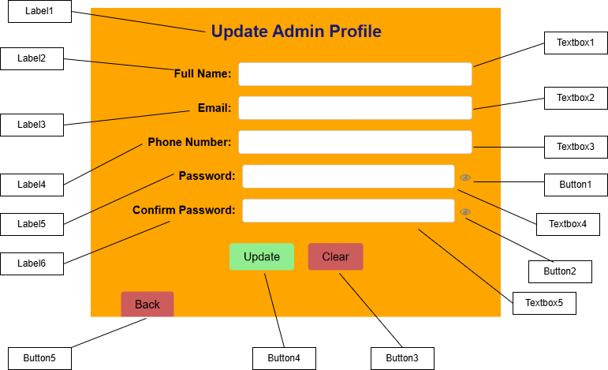

|  |  |  |
| --- | --- | --- |
| Control | Control Name | Description |
| Textbox1 | txtAdminName | Input field for the administrator's full name. |
| Textbox2 | txtAdminEmail | Input field for the administrator's email address. |
| Textbox3 | txtAdminPhone | Input field for the administrator's phone number. |
| Textbox4 | txtAdminPassword | . Input field for the administrator's password |
| Textbox5 | txtConfirmPass | Input field to re-enter and confirm the new password |
| Button1 | btnShowPass | Button to reveal or hide the text in the password field. |
| Button2 | btnShowConPass | Button to reveal or hide the text in the confirm password field. |
| Button3 | btnAdminClear | Button to clear all input fields on the form. |
| Button4 | btnAdminUpdate | Button to save and apply the updated admin profile information. |
| Button5 | btnAdminBack | Button to navigate back to the previous screen or dashboard. |
| Label1 | lblAdminProfile | Title label for the "Update Admin Profile" section. |
| Label2 | lblAdminName | Label for the "Full Name" input field. |
| Label3 | lblAdminEmail | Label for the "Email" input field. |
| Label4 | lblAdminPhone | Label for the "Phone Number" input field. |
| Label5 | lblAdminPassword | Label for the "Password" input field. |
| Label6 | lblAdminConfirmPass | Label for the "Confirm Password" input field. |

2.1.3 Manage Users form

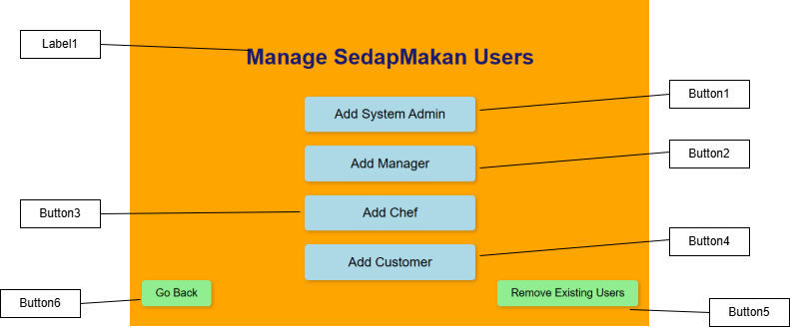

|  |  |  |
| --- | --- | --- |
| Control | Control Name | Description |
| Label1 | lblUsers | Title label for the "Manage SedapMakan Users" section. |
| Button1 | btnAddAdmin | Button to initiate the process of adding a new System Administrator user. |
| Button2 | btnAddManager | Button to initiate the process of adding a new Manager user. |
| Button3 | btnChef | Button to initiate the process of adding a new Chef user. |
| Button4 | btnAddCustomer | Button to initiate the process of adding a new Customer user. |
| Button5 | btnRemoveUsers | Button to initiate the process of removing existing users from the system. |
| Button6 | btnGoBack | Button to navigate back to the previous screen or menu. |

2.1.4 E-Wallet Report form

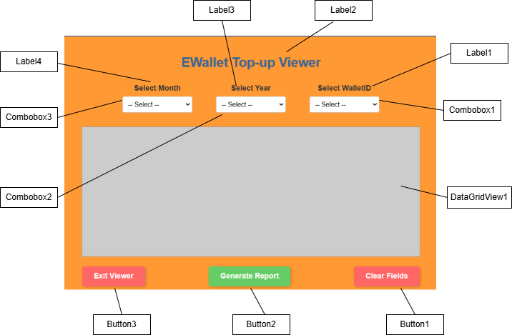

|  |  |  |
| --- | --- | --- |
| Control | Control Name | Description |
| Label1 | lblWalletID | Label for the "Select WalletID" dropdown |
| Label2 | lblEWalletViewer | Label for the "Select WalletID" dropdown |
| Label3 | lblYear | Label for the "Select Year" dropdown |
| Combobox1 | cmbWalletID | Dropdown menu to select a specific EWallet ID for filtering the report. |
| Combobox2 | cmbYear | Dropdown menu to select a specific year for filtering the report. |
| Combobox3 | cmbMonth | Dropdown menu to select a specific month for filtering the report. |
| DataGridView1 | dgvEWallet | A grid area where the EWallet top-up report data will be displayed |
| Button1 | btnClearFields | Button to clear all selected filter options in the dropdowns. |
| Button2 | btnEWalletReport | Button to generate and display the EWallet top-up report based on the selected filters. |
| Button3 | btnExitViewer | Button to close the EWallet top-up viewer windowand return previous screen. |

2.1.5 Sales Report form

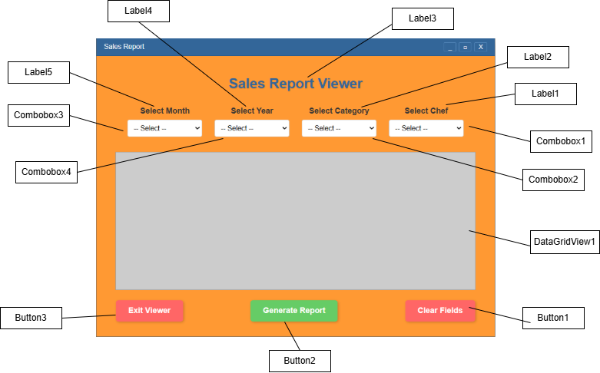

|  |  |  |
| --- | --- | --- |
| Control | Control Name | Description |
| Label1 | lblChef | .Label for the "Select Chef" dropdown |
| Label2 | lblCategory | Label for the "Select Category" dropdown |
| Label3 | lblSalesViewer | Main title label for the "Sales Report Viewer" |
| Label4 | lblYear | .Label for the "Select Year" dropdown |
| Label5 | lblMonth | Label for the "Select Month" dropdown |
| Combobox1 | cmbChef | Dropdown menu to select a specific chef for filtering the report. |
| Combobox2 | cmbCategory | Dropdown menu to select a sales category for filtering the report. |
| Combobox3 | cmbMonth | Dropdown menu to select a specific month for filtering the report. |
| Combobox4 | cmbYear | Dropdown menu to select a specific year for filtering the report. |
| DataGridView1 | salesDataGridView | A grid area where the sales report data will be displayed |
| Button1 | btnClearFields | Button to clear all selected filter options in the dropdowns. |
| Button2 | btnGenReport | Button to generate and display the sales report based on the selected filters. |
| Button3 | btnExitViewer | Button to close the sales report viewer window or return to a previous screen. |

2.2 Manager

2.2.1 Dashboard form

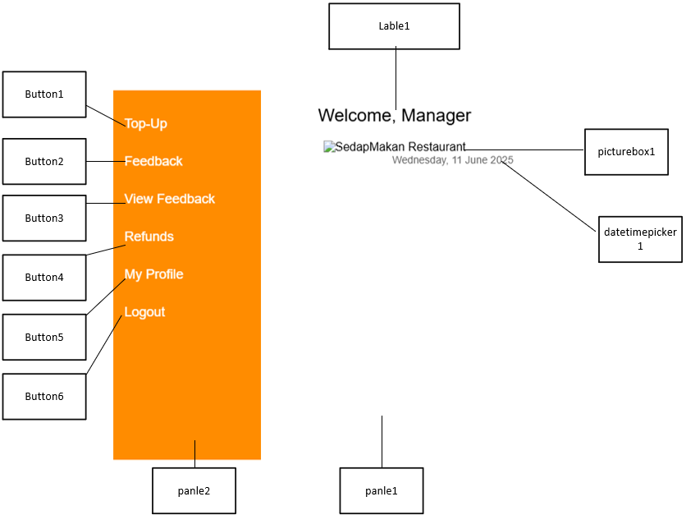

|  |  |  |
| --- | --- | --- |
| Control | Control Name | Description |
| Button1 | btnTopUp | Move to TopUp_manager form |
| Button2 | btnFeedback | Move to Feedback_manager form |
| Button3 | btnViewFeedback | Move to ViewFeedback_manger form |
| Button4 | btnRefunds | Move to Refunds_manager form |
| Button5 | btnProfile | Move to Myprofile_manager form |
| Button6 | btnLogout | Return to Login form |
| Lable1 | lblManagerName | To lable the Manager using the system |
| picturebox1 | picturebox1 | Displays photo of the restaurant |
| datatimepicker1 | datetimepicker1 | Displays time and date |
| panle1 | panleMain | Allow grouping controls |
| panle2 | panleSidebar | Allow grouping controls  2 |

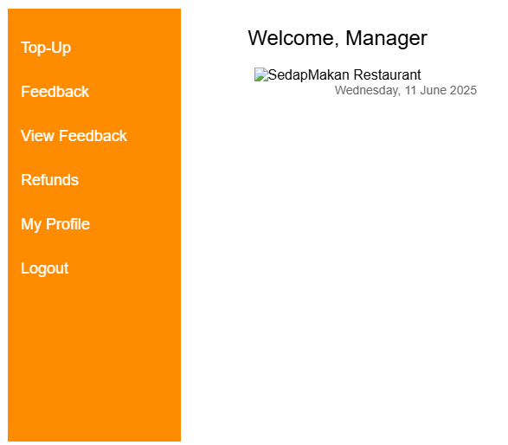

2.2.2 Profile form

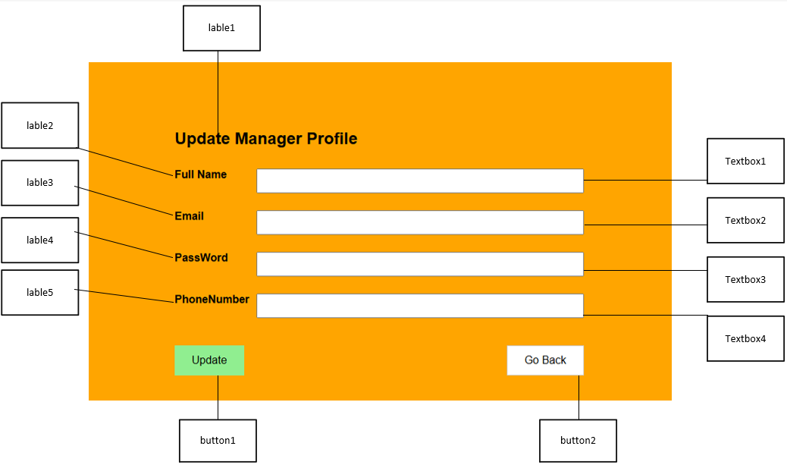

|  |  |  |
| --- | --- | --- |
| Control | Control Name | Description |
| Lable1 | lblHead | To label the related controls for updating Manager Information |
| Lable2 | lblName |
| Lable3 | lblEmail |
| Lable4 | lblPassword |
| Lable5 | lblNumber |
| Textbox1 | txtFullname | Takes input as Fullname |
| Textbox2 | txtEmail | Takes input as Email |
| Textbox3 | txtPassword | Takes input as Password |
| Textbox4 | txtPhone | Takes input as Phonenumber |
| Button1 | btnUpdate | To update info in the SQL table |
| Button2 | btnGoBack | To return to the ManagerDashboard |

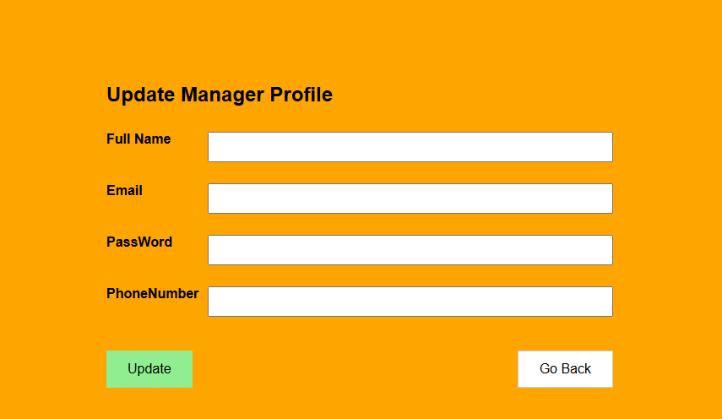

2.2.3 View & Respond Feedback form

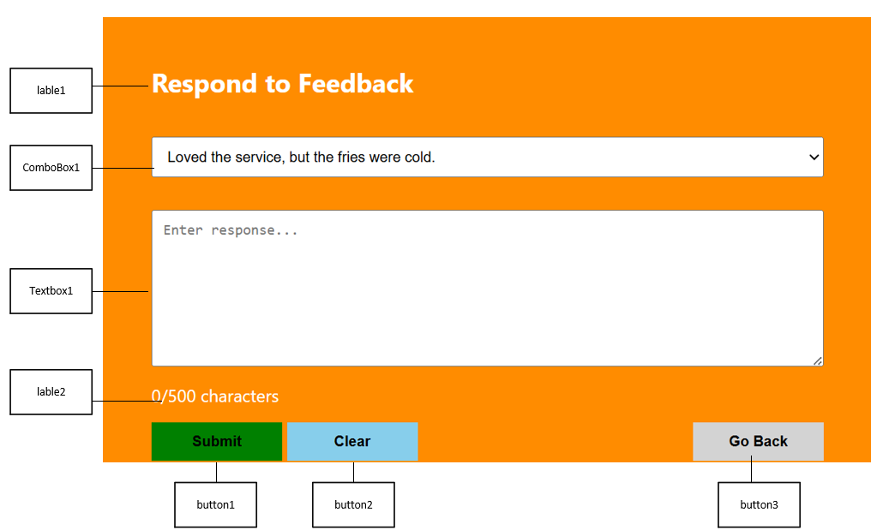

|  |  |  |
| --- | --- | --- |
| Control | Control Name | Description |
| button1 | btnSubmit | Updates the status of feedback in the database |
| button2 | btnClear | Clears the Textbox |
| button3 | btnGoBack | To return to the ManagerDashboard |
| lable1 | lblHeading | To display the purpose of the form |
| lable2 | lblCharCount | To display limit for the feedback respond |
| Textbox1 | txtResponse | Accepts input from manager (feedback) |
| ComboBox1 | cbFeedback | To choose a feedback to respond |

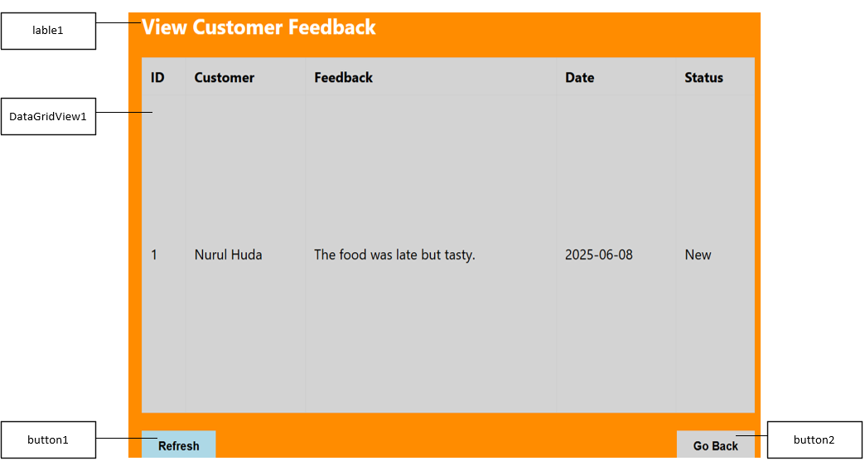

|  |  |  |
| --- | --- | --- |
| Control | Control Name | Description |
| lable1 | lblHeading | To display the purpose of the form |
| DataGridView1 | dgvviewFB | To display all the feedback available |
| button1 | btnRefresh | Refresh the datagridview |
| button2 | btnGoBack | To return to the ManagerDashboard |

2.2.4 E-Wallet Top-up form

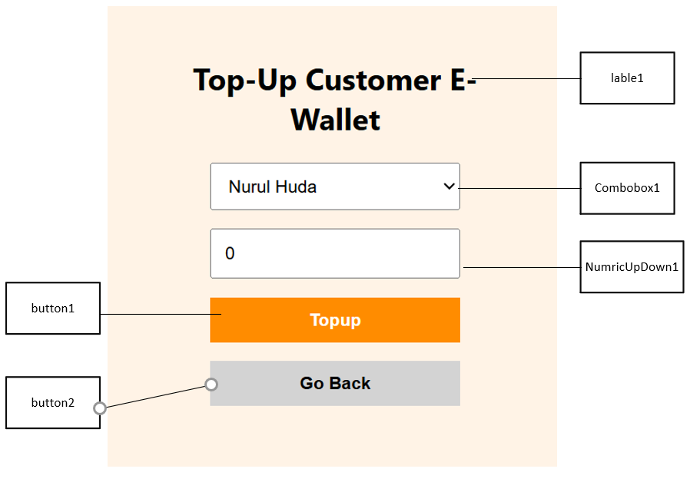

|  |  |  |
| --- | --- | --- |
| Control | Control Name | Description |
| button1 | btnTopUp | To update the E_wallet table in database |
| button2 | btnGoBack | To return to the ManagerDashboard |
| lable1 | lblHeading | To lable and display the Heading of form |
| Combobox1 | cbCustomer | To choose a to TopUp to his wallet |
| NumricUpDown1 | NumAmount | To choose the amount wanted to topup |

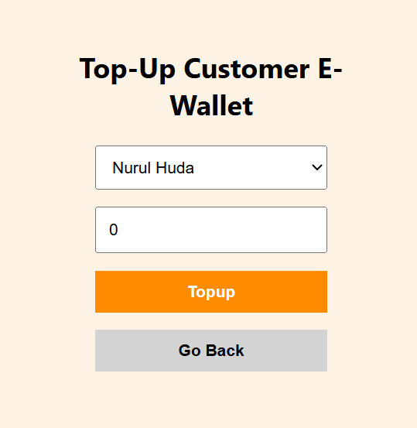

2.2.5 Refund Approval form

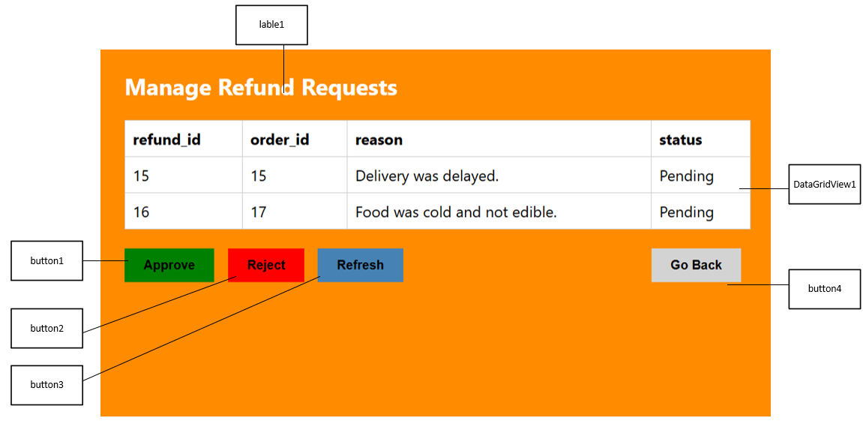

|  |  |  |
| --- | --- | --- |
| Control | Control Name | Description |
| button1 | btnApprove | Approve the refund and update it in the database |
| button2 | btnRejct | Rejects the refund and update it in the database |
| button3 | btnRefresh | To refresh Datagrid for new refunds |
| button4 | btnGoBack | To return to the ManagerDashboard |
| DataGridView1 | dgvRefunds | To display the refunds available in the table |
| lable1 | lblHeading | To display the purpose of the form |

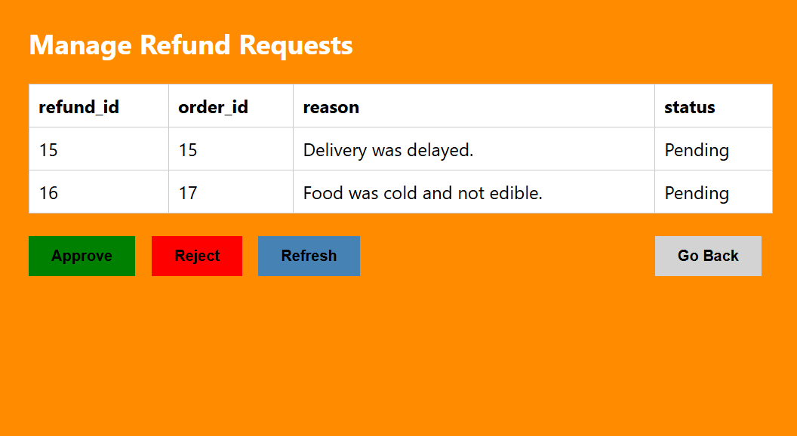

2.3 Chef

2.3.1 Dashboard form

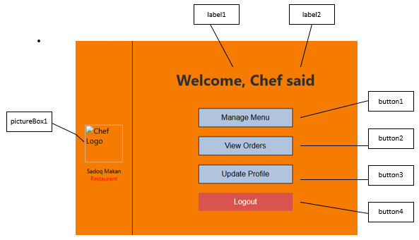

|  |  |  |
| --- | --- | --- |
| Control | Control Name | Description |
| Label1 | lblWelcome | Displays welcome text, "Welcome, chef" |
| Label2 | lblChefName | Displays the chef's name dynamically |
| PictureBox1 | picLogo | Displays the restaurant logo |
| Button1 | btnManageMenu | Navigates to the menu management screen |
| Button2 | btnViewOrders | Opens the chef’s orders list |
| Button3 | btnUpdateProfile | Opens profile update form |
| Button4 | btnLogout | Logs the user out of the application |

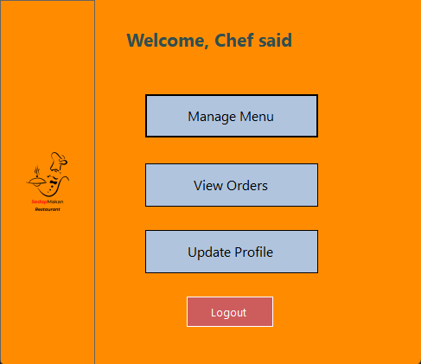

2.3.1 Profile form

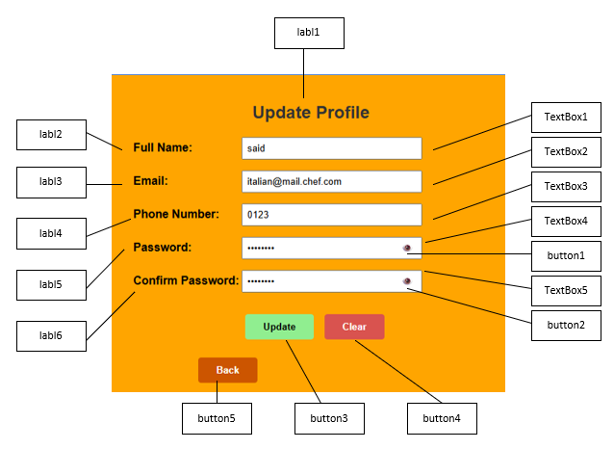

|  |  |  |
| --- | --- | --- |
| **Control** | **Control Name** | **Description** |
| **Label1** | lblTitle | To label the form title “Update Profile” |
| Label2 | lblName | To label the input for full name |
| Label3 | lblEmail | To label the input for email |
| Label4 | lblPhoneNumber | To label the input for phone number |
| Label5 | lblPassword | To label the input for password |
| Label6 | lblConfirmPassword | To label the input for confirming password |
| **TextBox1** | txtName | Takes input as Full Name |
| TextBox2 | txtEmail | Takes input as Email |
| TextBox3 | txtPhone | Takes input as Phone Number |
| TextBox4 | txtPassword | Takes input as Password |
| TextBox5 | txtConfirmPassword | Takes input as Confirm Password |
| **Button1** | btnShowPass1 | Toggles visibility and casched of password field |
| Button2 | btnShowPass2 | Toggles visibility and cashed of confirm password field |
| Button3 | btnUpdate | Submits updated profile information |
| Button4 | btnClear | Clears all input fields |
| Button5 | btnBack | Returns to the previous screen (Back button) |

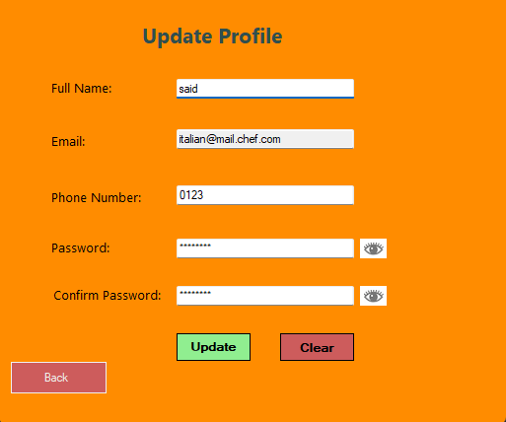

2.3.3 Menu Manag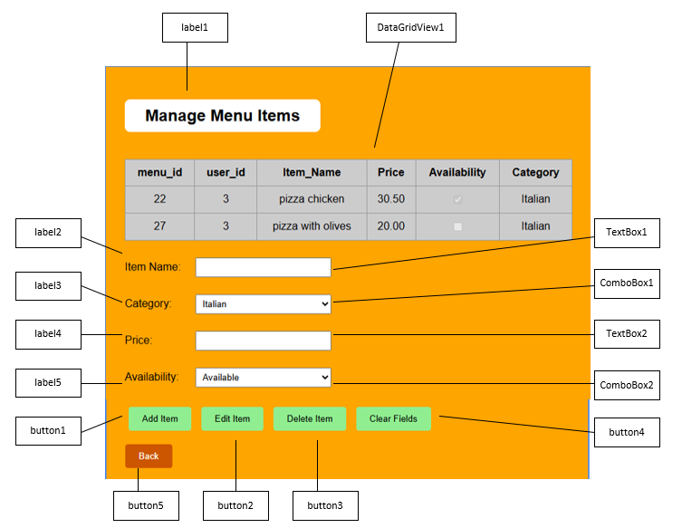

|  |  |  |
| --- | --- | --- |
| Control | Control Name | Description |
| Label1 | lblTitle | To label the form title "Manage Menu Items" |
| Label2 | lblName | To label the input for item name |
| Label3 | lblCategory | To label the input for item category |
| Label4 | lblPrice | To label the input for item price |
| Label5 | lblAvailability | To label the input for availability |
| TextBox1 | txtName | Takes input as Item Name |
| TextBox2 | txtPrice | Takes input as Price |
| ComboBox1 | cmbCategory | Dropdown to select Item Category |
| ComboBox2 | cmbAvailability | Dropdown to select availability (Available,no availble) |
| DataGridView1 | dgvMenuItems | Displays the list of menu items |
| Button1 | btnAdd | Adds new menu item |
| Button2 | btnEdit | Edits selected menu item |
| Button3 | btnDelete | Deletes selected menu item |
| Button4 | btnClear | Clears all input fields |
| Button5 | btnBackToDashBoard | Goes back to the Dashboardfrom |

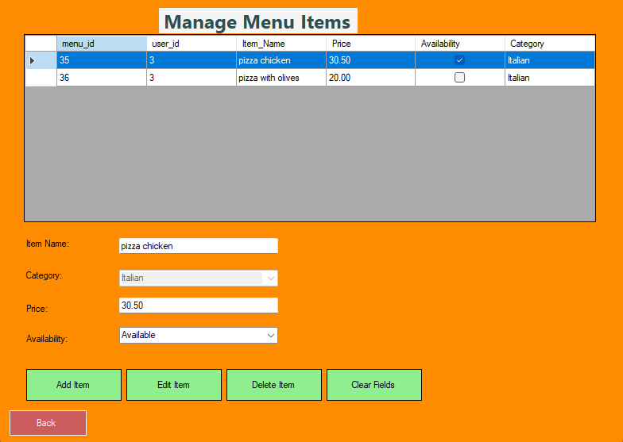

2.3.4 Order List form

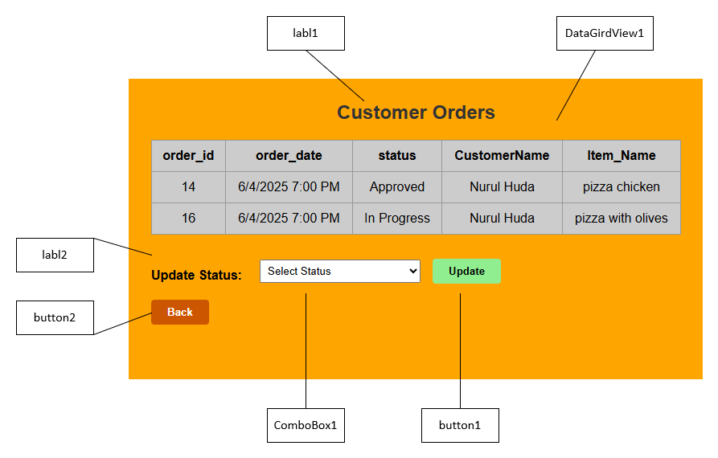

|  |  |  |
| --- | --- | --- |
| **Control** | **Control Name** | **Description** |
| **Label1** | lblTitle | Displays the form title "Customer Orders" |
| Label2 | lblStatus | Label for the status update dropdown |
| **ComboBox1** | cmbStatus | Dropdown to select new order status |
| **DataGridView1** | dgvOrders | Displays list of all customer orders |
| **Button1** | btnUpdate | Applies the selected status to the chosen order |
| Button2 | btnBack | Returns to the previous screen |

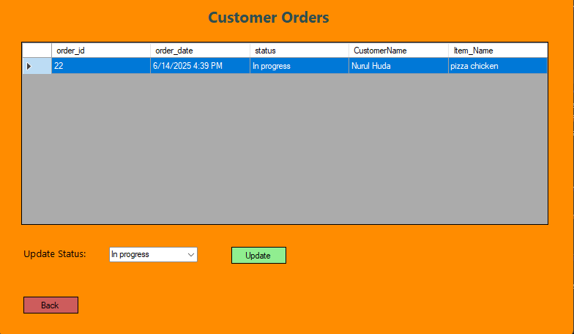

2.4 Customer

2.4.1 Dashboard form

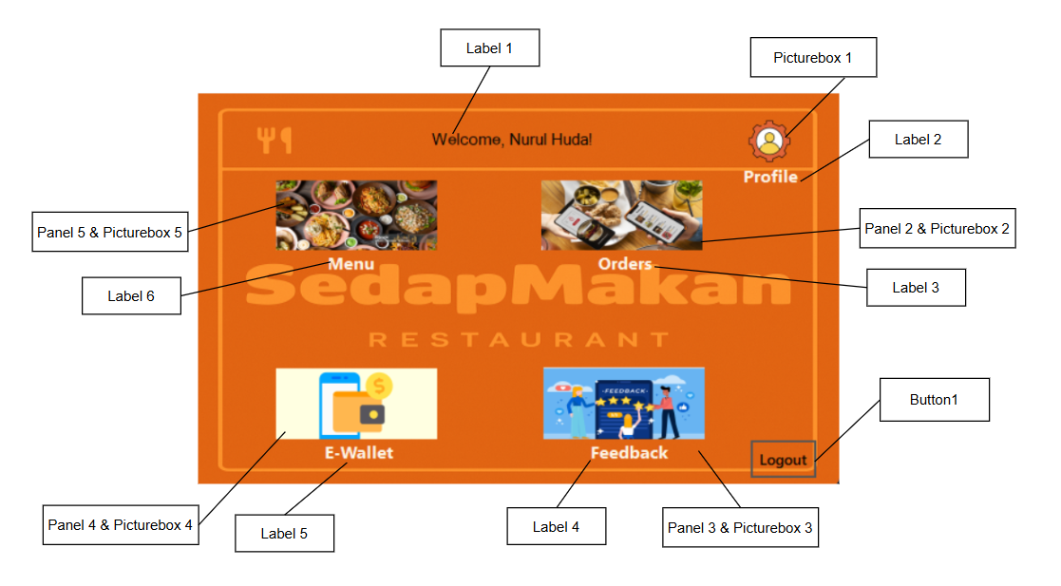

|  |  |  |
| --- | --- | --- |
| Control | Control Name | Description |
| Label 1 | lblWelcome | To show a Welcome message with the user’s name |
| Label 2 | Lblprofile | Label for profile |
| Label 3 | lblOrder | Label for Orders |
| Label 4 | lblFeedback | Label for Feedback |
| Label 5 | lblEwallet | Label for E-wallet |
| Label 6 | lblMenu | Label for Menu |
| Picturebox 1 | pictureBox1 | Clickable image which takes user to Profile |
| Panel 2 & Picturebox 2 | panelOrders & picOrders | Clickable image which takes user to Orders |
| Panel 3 & Picturebox 3 | panelFeedback & picFeedback | Clickable image which takes user to Feedback |
| Panel 4 & Picturebox 4 | panelEwallet & picEwallet | Clickable image which takes user to Ewallet |
| Panel 5 & Picturebox 5 | panelMenu & picMenu | Clickable image which takes user to Menu |
| Button 1 | btnLogout | To logout |

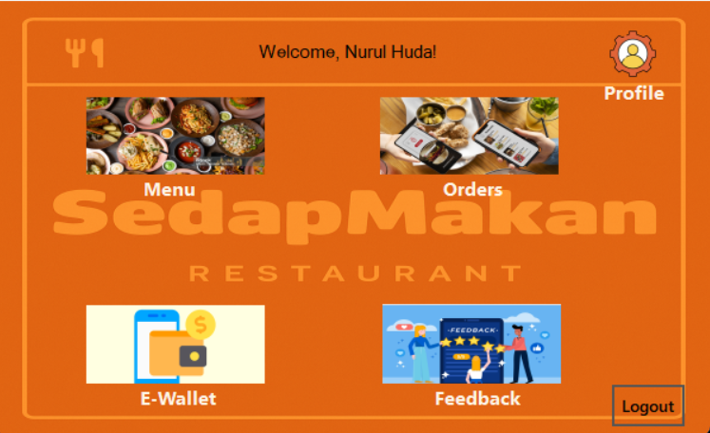

2.4.2 Profile form

1, Update Profile

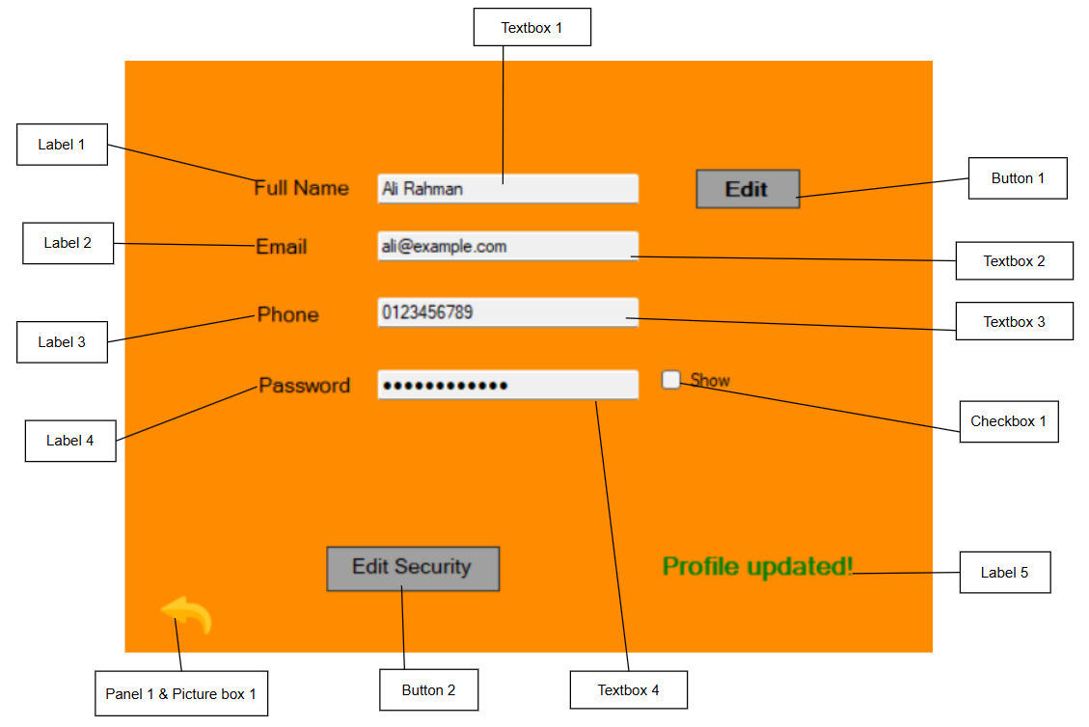

|  |  |  |
| --- | --- | --- |
| Control | Control Name | Description |
| Label 1 | lblName | To label Name |
| Label 2 | lblEmail | To label Email |
| Label 3 | lblPhone | To label Phone |
| Label 4 | lblPassword | To label Password |
| Label 5 | lblStatus | Shows if user’s profile is updated or not |
| Button 1 | btnEdit | To edit Profile |
| Button 2 | btnEditSecurity | To edit Security measures |
| Textbox 1 | txtName | Takes input as Full name |
| Textbox 2 | txtEmail | Takes input as Email |
| Textbox 3 | txtPhone | Takes input as Phone number |
| Textbox 4 | txtPassword | Takes input as Password |
| Checkbox 1 | chkShowPass | To unhide Password |
| Panel 1 & Picturebox 1 | goback1 & picgoback1 | Goes back to customer dashboard |

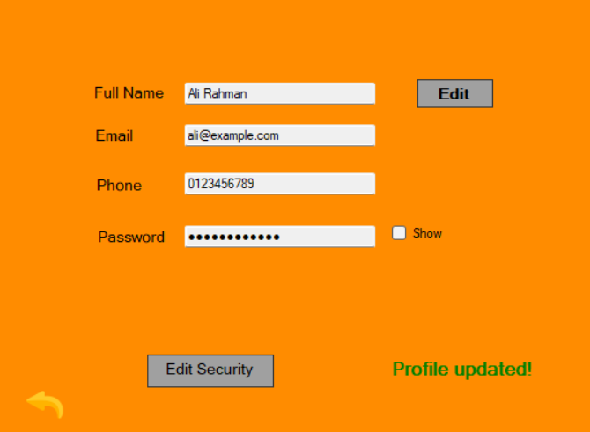

2, Update Security Information

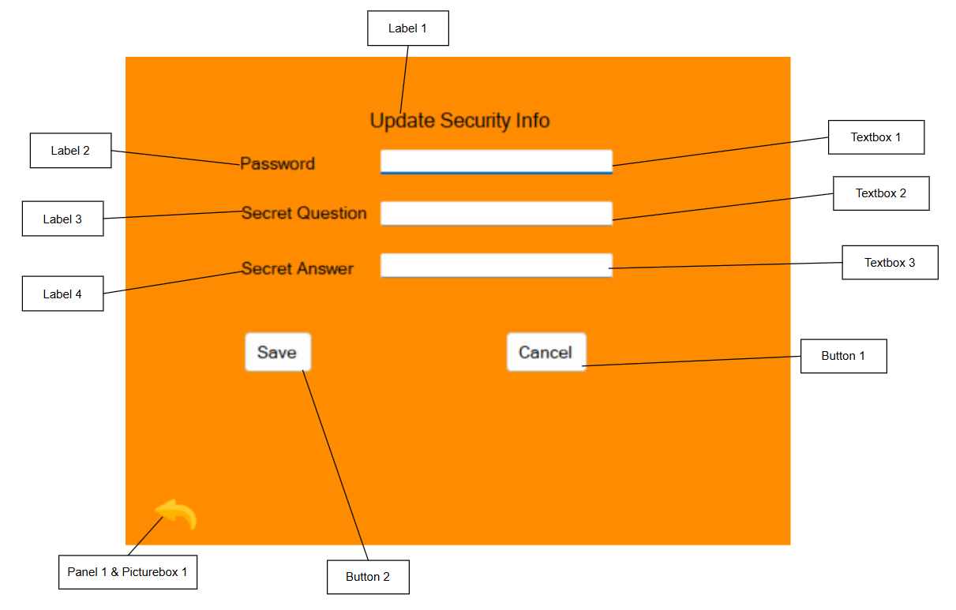

|  |  |  |
| --- | --- | --- |
| Control | Control Name | Description |
| Label 1 | lblSecHeading | To label Update Security Info |
| Label 2 | label1 | To label Password |
| Label 3 | label2 | To label Secret Question |
| Label 4 | label3 | To label Secret Answer |
| Button 1 | btnCancelSecurity | To cancel and go back to edit profile |
| Button 2 | btnSaveSecurity | Saves new Security Info |
| Textbox 1 | txtConfirmPassword | Takes input as Password |
| Textbox 2 | txtSecretQuestion | Takes input as Question |
| Textbox 3 | txtSecretAnwser | Takes input as Answer |
| Panel 1 & Picturebox 1 | goback1 & picgoback1 | Goes back to Customer dashboard |

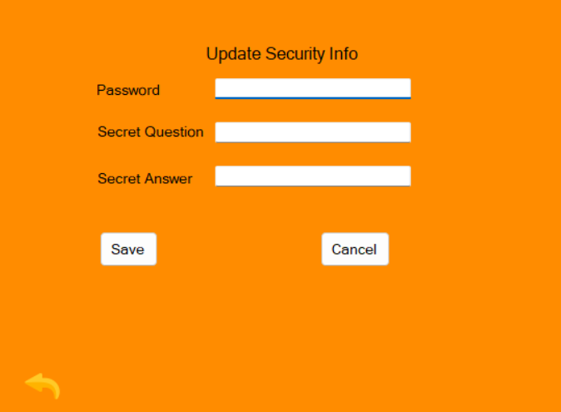

2.4.3 Menu form

1, Menu

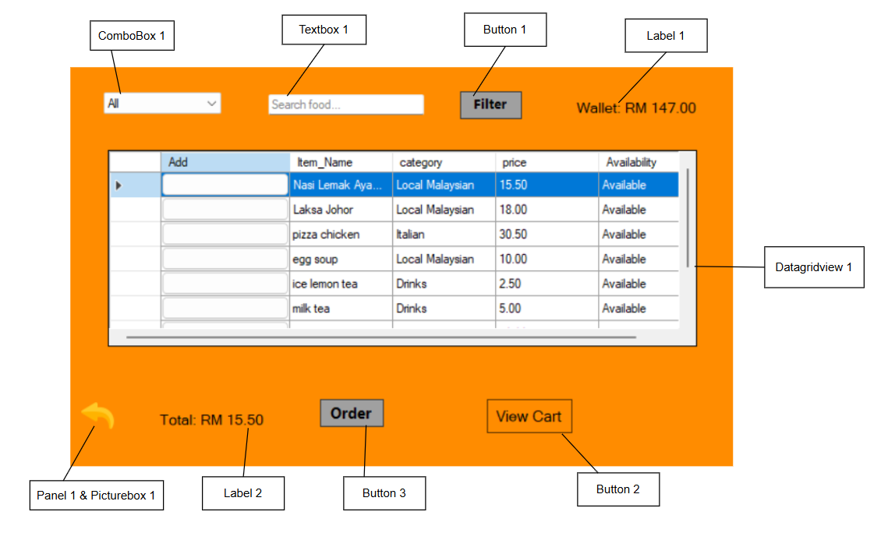

|  |  |  |
| --- | --- | --- |
| Control | Control Name | Description |
| Label 1 | lblWalletBalance | Shows total balance in user’s Wallet |
| Label 2 | lblCartTotal | Shows the total of items in cart |
| Datagridview 1 | dgvMenu | Shows Menu details |
| ComboBox 1 | cmbCategory | Toggle different Categories |
| Button 1 | btnFilter | To Filter menu |
| Button 2 | btnViewCart | Views cart |
| Button 3 | btnPlaceOrder | To place Order |
| Textbox 1 | txtSearch | To search |
| Panel 1 & Picturebox 1 | goback2 & picgoback2 | Goes back to customer dashboard |

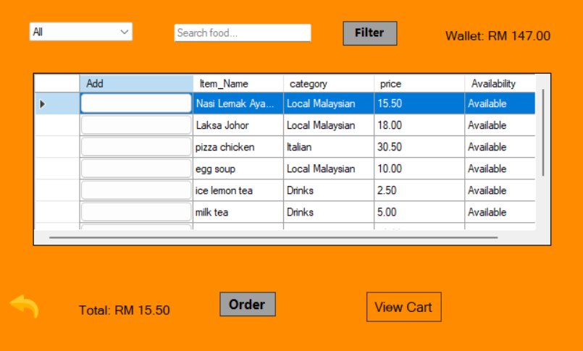

2, Cart

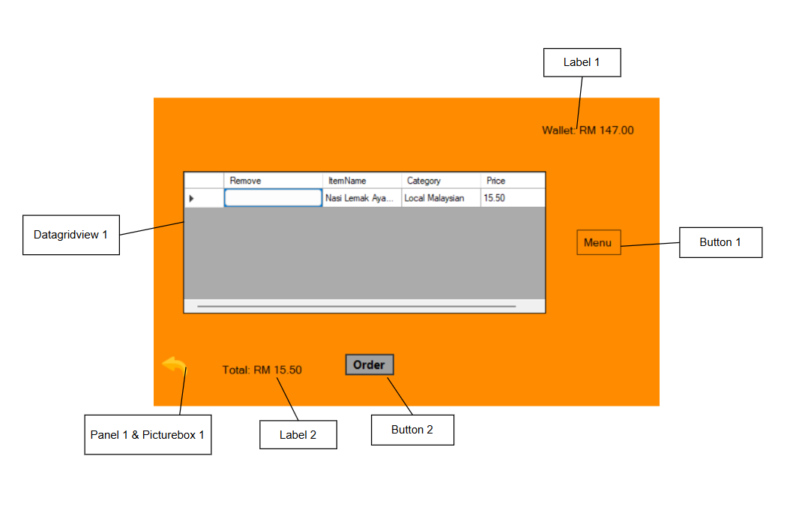

|  |  |  |
| --- | --- | --- |
| Control | Control Name | Description |
| Label 1 | lblWalletBalance | Shows total balance in user’s Wallet |
| Label 2 | lblCartTotal | Shows the total of items in cart |
| Datagridview 1 | dgvCart | To view Cart items |
| Button 1 | btnBacktoMenu | Takes back user to menu |
| Button 2 | btnPlaceOrder | To place Order |
| Panel 1 & Picturebox 1 | goback2 & picgoback2 | Goes back to customer dashboard |

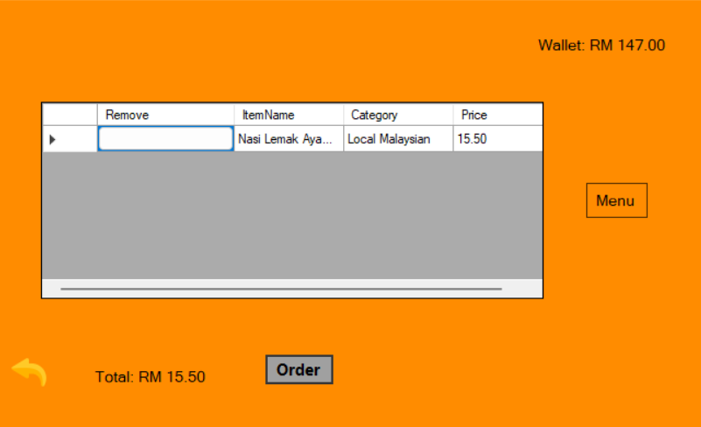

2.4.4 Orders form

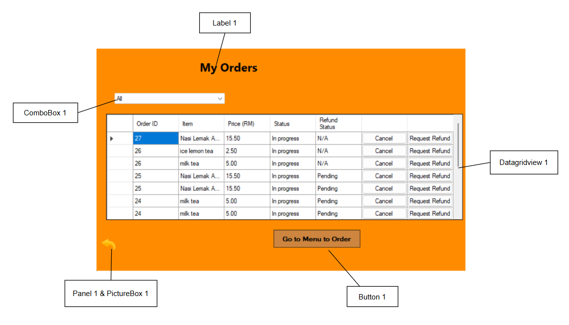

|  |  |  |
| --- | --- | --- |
| Control | Control Name | Description |
| Label 1 | lblTitle | To Label My Orders |
| Datagridview 1 | dgvOrders | View Past orders |
| Button 1 | btnGoToMenu | Takes user to menu form to order |
| ComboBox 1 | cmbStatusFilter | Filters Status |
| Panel 1 & Picturebox 1 | goback3 & picgoback3 | Goes back to customer dashboard |

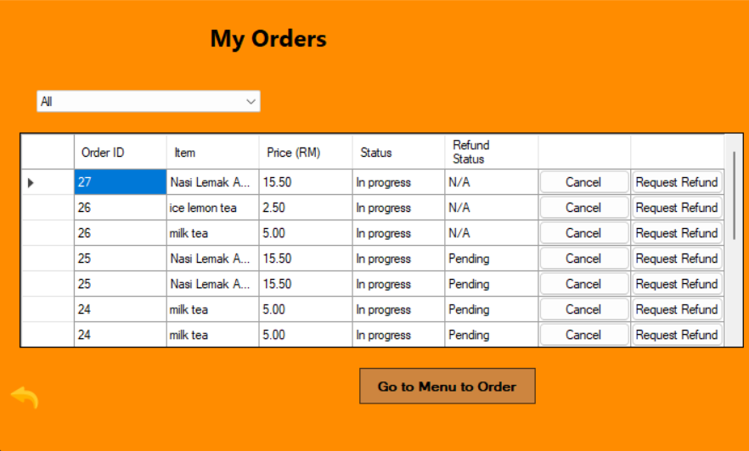

2.4.5 E-Wallet Form

1, Top-up History

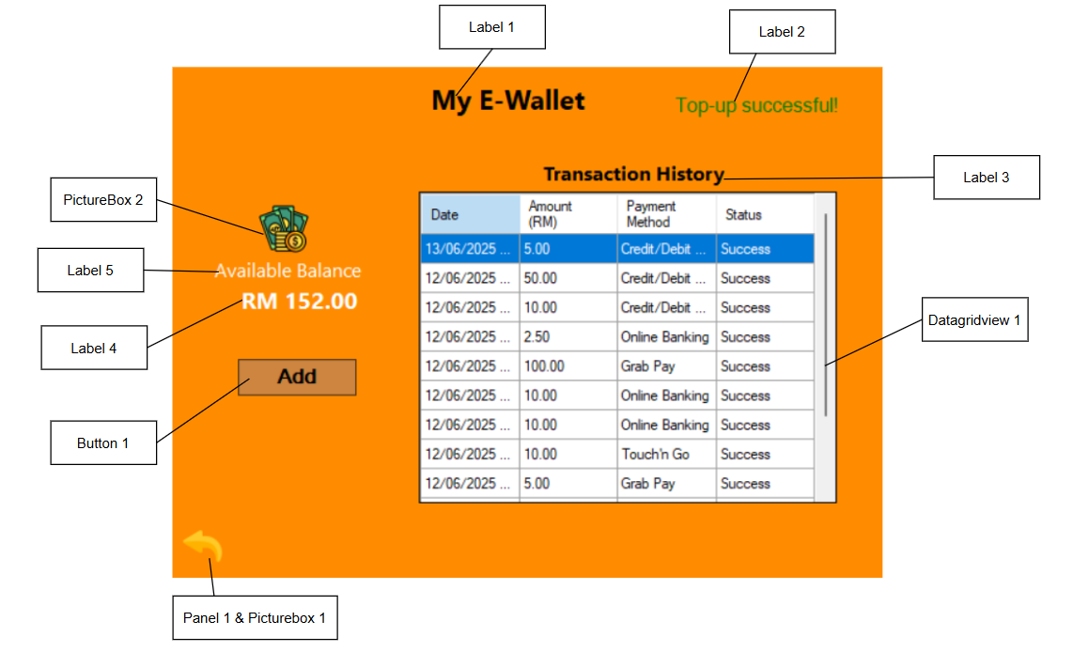

|  |  |  |
| --- | --- | --- |
| Control | Control Name | Description |
| Label 1 | lblTitle | To label My E-Wallet |
| Label 2 | lblStatus | To get a Confirmation for successful Top-up |
| Label 3 | lblTransactionHistory | To label TransactionHistory |
| Label 4 | lblBalance | To show current available balance |
| Label 5 | lblBalanceTitle | To label Available Balance |
| Datagridview 1 | dgvHistory | To show past transactions |
| Button 1 | btnAddFunds | To add Funds |
| Panel 1 & Picturebox 1 | goback4 & picgoback4 | Takes input as Email |
| Picturebox 2 | pictureBox1 | Image of a digital wallet |

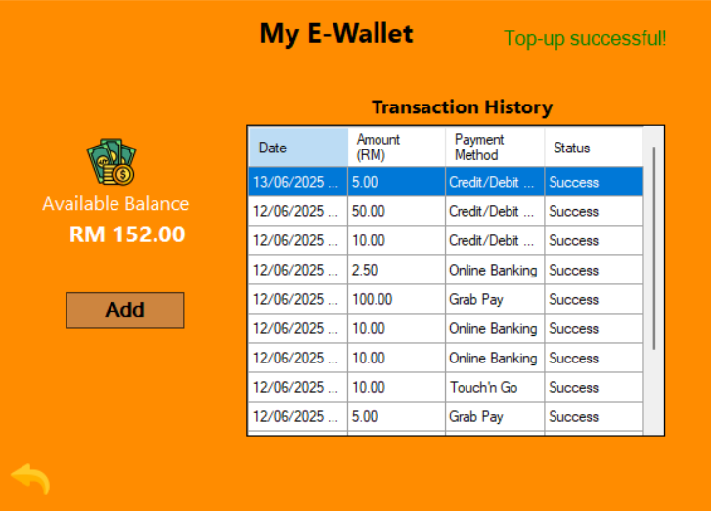

2, E-wallet

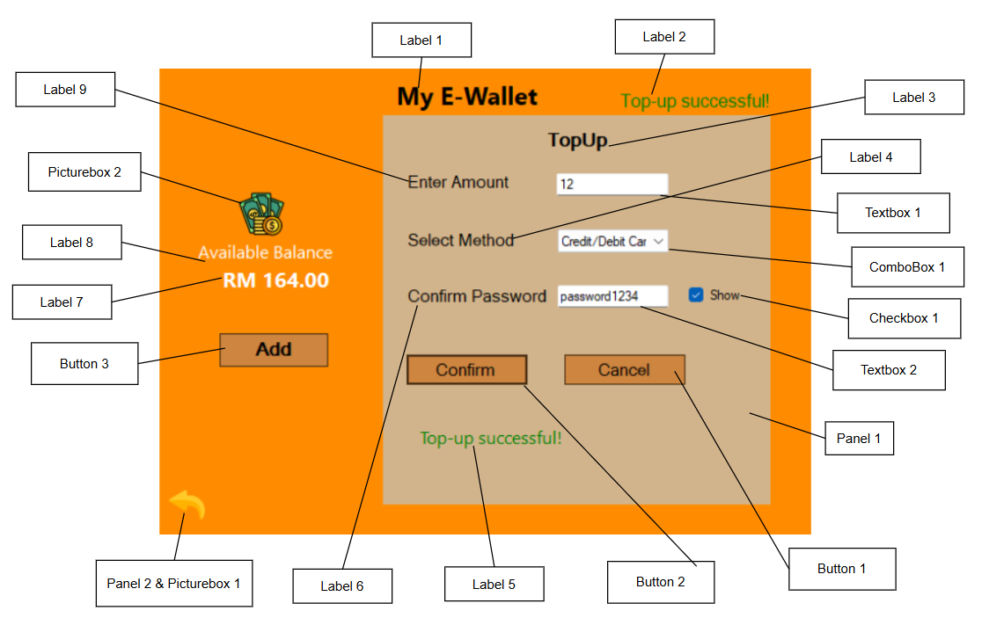

|  |  |  |
| --- | --- | --- |
| Control | Control Name | Description |
| Label 1 | lblTitle | To label My E-Wallet |
| Label 2 | lblStatus | To get a Confirmation for successful Top-up |
| Label 3 | lblTopup | To label Top-up |
| Label 4 | lblMethod | To label Method |
| Label 5 | lblTopupMessage | To display a confirmation message |
| Label 6 | lblPassword | To label Confirm password |
| Label 7 | lblBalance | To show current available balance |
| Label 8 | lblBalanceTitle | To label Available Balance |
| Label 9 | lblTopUpAmount | To label Enter Amount |
| Button 1 | btnCancelTopUp | To Cancel Top-up and go back to E-wallet menu |
| Button 2 | btnConfirmTopUp | To Confirm Top-up |
| Button 3 | btnAddFunds | To add Funds |
| Textbox 1 | txtTopUpAmount | To insert Top-up amount |
| Textbox 2 | txtTopUpPassword | To insert user password |
| ComboBox 1 | cmbMethod | To Select Method for Payment |
| Panel 1 | pnlTopUp | To display Top-up menu |
| Checkbox 1 | chkShowPassword | To unhide password |
| Panel 2 & Picturebox 1 | goback4 & picgoback4 | Goes back to customer dashboard |
| Picturebox 2 | pictureBox1 | Image of a digital wallet |

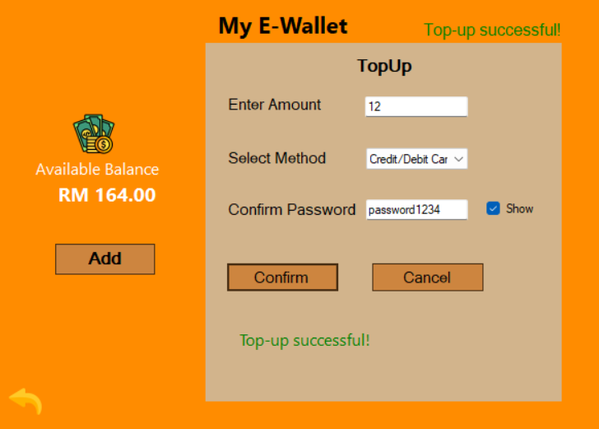

2.4.6 Feedback form

1, Feedback

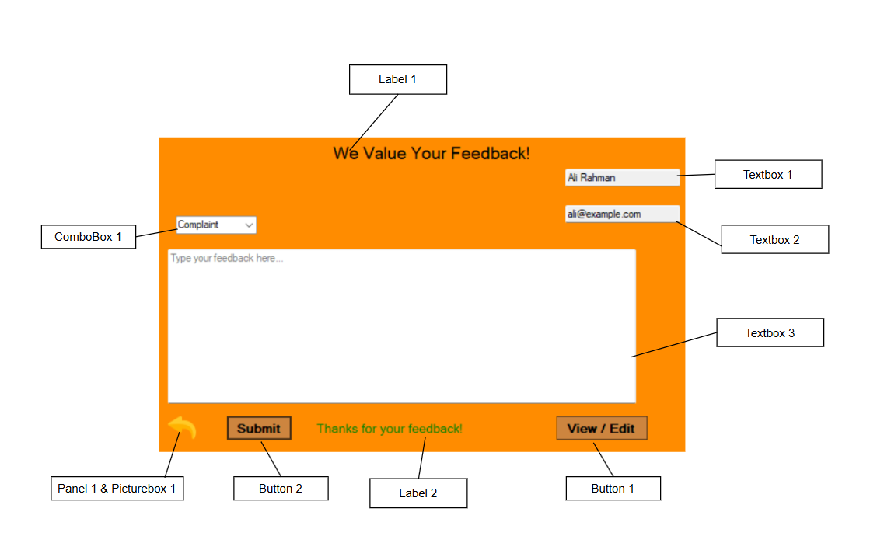

|  |  |  |
| --- | --- | --- |
| Control | Control Name | Description |
| Label 1 | lblTitle | To label We Value Your Feedback! |
| Label 2 | lblStatus | To display a Thank you message |
| Textbox 1 | txtName | To show user’s Name |
| Textbox 2 | txtEmail | To show user’s Email |
| Textbox 3 | txtFeedback | To insert user feedback |
| ComboBox 1 | cmbType | To select type of feedback |
| Button 1 | btnViewFeedbacks | To toggle between viewing or editing feedback |
| Button 2 | btnSumbit | To submit Feedback |
| Panel 1 & Picturebox 1 | Goback5 & picgoback5 | Goes back to customer dashboard |

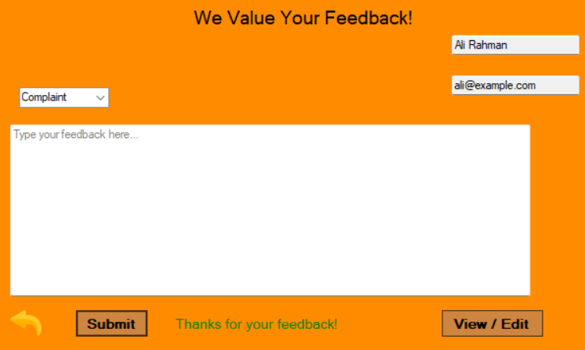

2, Previous Feedback

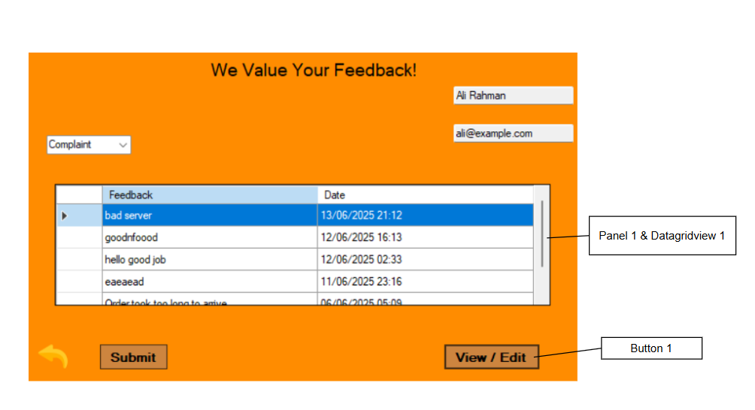

|  |  |  |
| --- | --- | --- |
| Control | Control Name | Description |
| Button 1 | btnViewFeedbacks | To toggle between viewing or editing feedback |
| Panel 1 & Datagridview 1 | pnlPrevious & dgvPreviousFeedback | To show previous feedbacks |

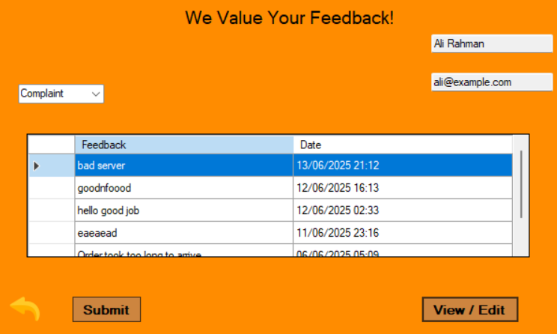

CHAPTER 3: USE-CASE DIAGRAM

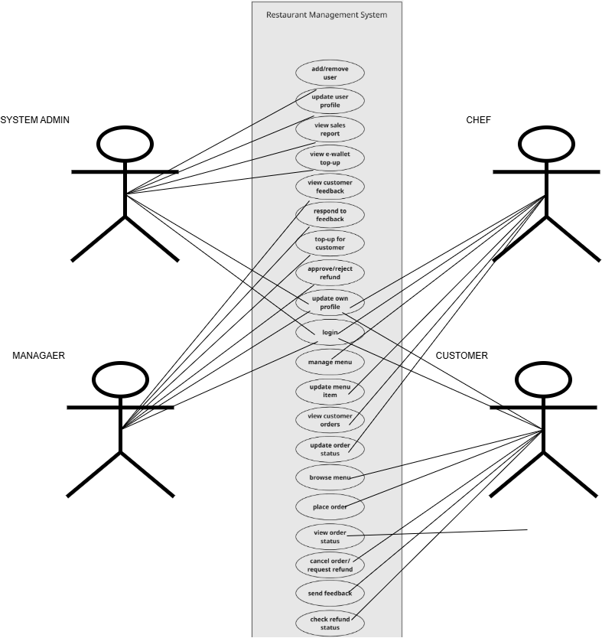

The Use Case Diagram above illustrates the functional interactions between different user roles and the Restaurant Management System. Four primary actors—**System Admin**, **Manager**, **Chef**, and **Customer**—are identified, each performing specific actions based on their roles. The **System Admin** manages users, updates profiles, views sales reports, and oversees e-wallet and feedback activities. The **Manager** is responsible for customer service operations such as responding to feedback, processing refunds, and topping up customer e-wallets. **Chefs** interact with the system to manage menus and update order statuses, while **Customers** engage with the system to browse the menu, place orders, submit feedback, and request refunds. This diagram effectively captures the role-based access and interaction points, ensuring that each user has the appropriate permissions and responsibilities within the system.

CHAPTER 4: CLASS DIAGRAM

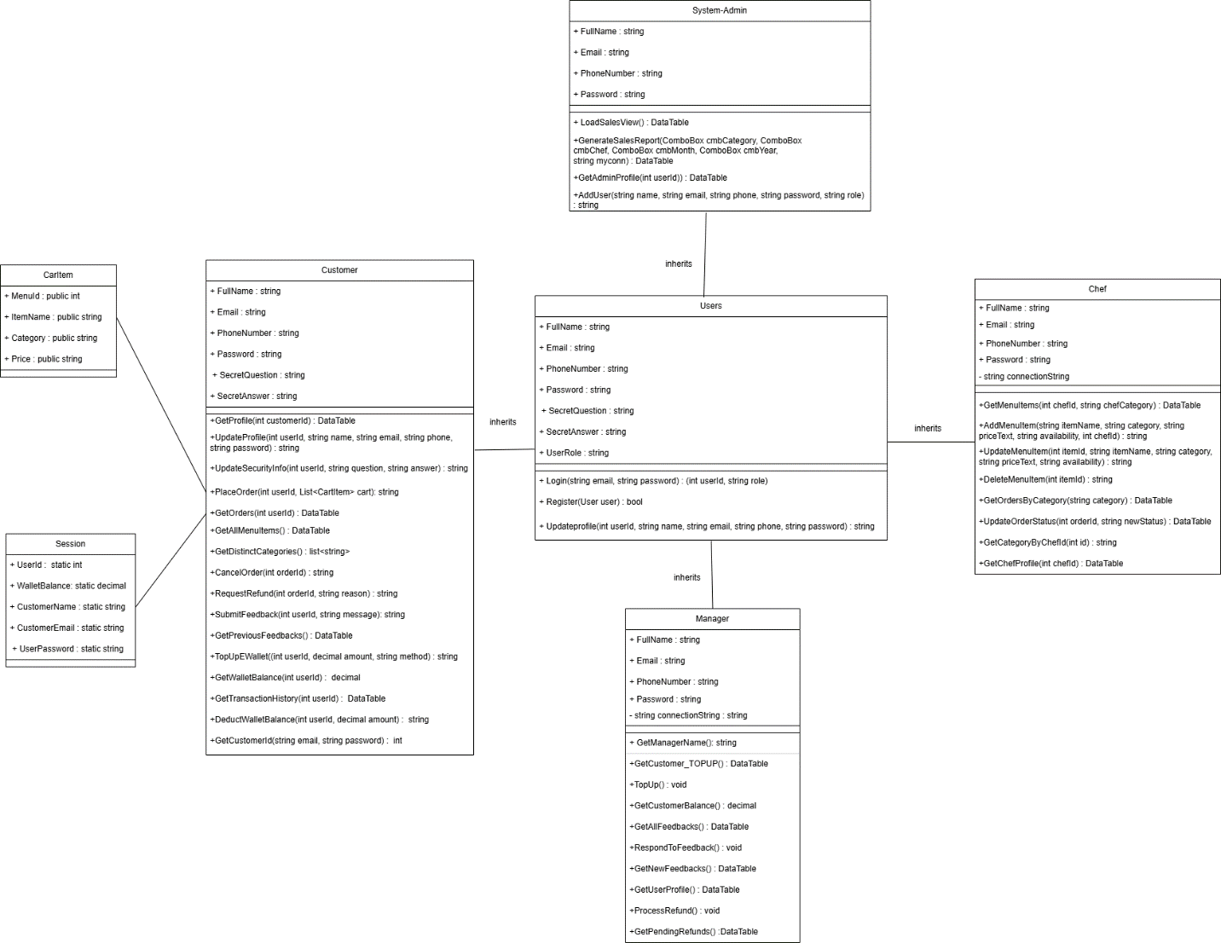

CHAPTER 5: EXPLANATION OF CODES & METHODS IMPLEMENTED

5.1 System Admin

SystemAdmin Class

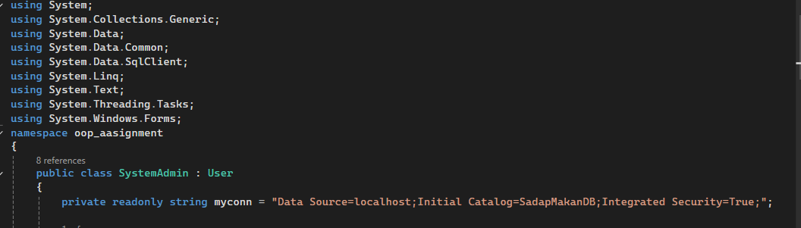

The SystemAdmin class in oop_assignment inherits from the User class, establishing an "is-a" relationship. This OOP design promotes code reusability, allowing SystemAdmin to automatically access public and protected User members (e.g., username, email). This avoids duplication and ensures consistent base functionalities. The class also contains a private readonly database connection string (myconn) for direct SadapMakanDB interaction.

**Method: LoadSalesView()**

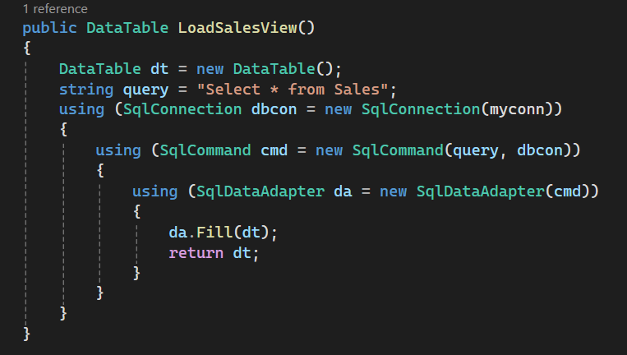

This method is designed to retrieve **all records** from the Sales table in the database.  
It performs the operation in a simple sequence:

1. It creates a blank DataTable object in memory.
2. Executes a SELECT * FROM Sales SQL command using a SqlConnection.
3. Uses a SqlDataAdapter to fill the DataTable with the result set.
4. Returns the filled DataTable, which contains all the sales data

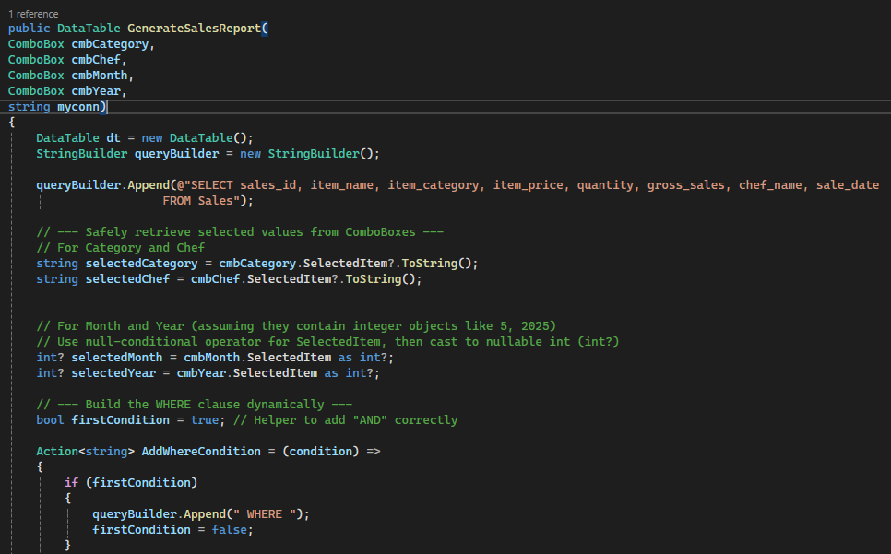Method: GenerateSalesReport (…)

The GenerateSalesReport method is used to dynamically generate a filtered sales report based on user-selected criteria from four ComboBoxes: cmbCategory, cmbChef, cmbMonth, and cmbYear. It retrieves data from the Sales table and returns the result as a DataTable. The method begins by constructing a SQL query using a StringBuilder, and it appends WHERE clauses based on which filters are selected. For example, if the user chooses a specific item category and a chef, the query will only return sales matching those filters.

The month and year filters are applied using SQL's MONTH() and YEAR() functions to match the sale_date. Parameters are safely added to prevent SQL injection. After building the final query, the method executes it using a SqlCommand and fills the DataTable using a SqlDataAdapter. If any errors occur during execution, they are caught and displayed using a message box for user-friendly feedback. The returned DataTable can be used to populate UI components like DataGridView.

Method: GetAdminProfile(…)

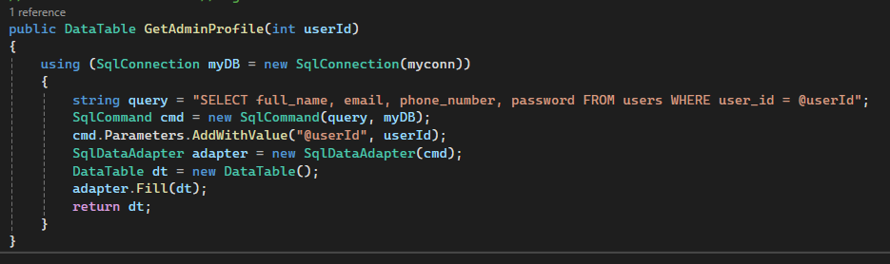

The GetAdminProfile method retrieves profile details of an admin user based on their userId. It connects to the database using a SqlConnection and executes a parameterized SQL query to securely fetch the full_name, email, phone_number, and password fields from the users table. A SqlDataAdapter is used to execute the query and populate the results into a DataTable. The filled DataTable is then returned for use in the application, such as displaying profile details in an admin dashboard. Parameterization ensures protection against SQL injection, making this method secure and efficient for user data retrieval.

Method: AddUser(…)

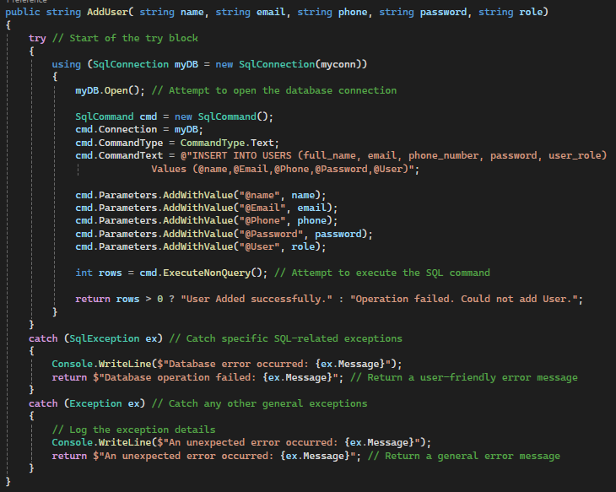

The AddUser method is responsible for inserting a new user into the USERS table of a database. It accepts five parameters—name, email, phone, password, and role—which represent the user's personal and role-related details. Using a SqlConnection, the method opens a connection to the database and prepares an INSERT SQL command using SqlCommand.

The query uses parameters (@name, @Email, etc.) to prevent SQL injection and safely inject user data. The ExecuteNonQuery() method is then called to perform the insert operation, returning the number of affected rows. If at least one row is inserted, it returns a success message; otherwise, it returns a failure message.

The method includes robust exception handling:

* If a SqlException occurs (e.g., connection issues, constraint violations), it logs the error and returns a database-specific message.
* For any general exceptions, it logs and returns a fallback error message.

5.2 Manager

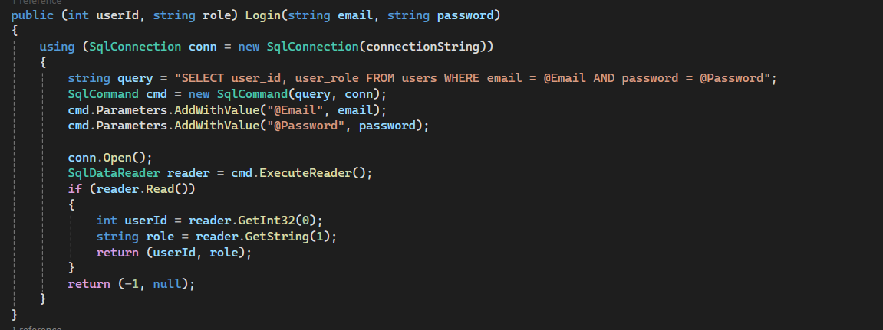

The Login () method is defined inside the User class and is responsible for authenticating users (Manager, Chef, Customer) against the users table in the database. It takes two inputs: an email and a password. If the credentials are valid, the method returns a tuple containing the user_id and user_role from the database. These values are then used to determine which dashboard or role-specific screen to display.

**Manager Class**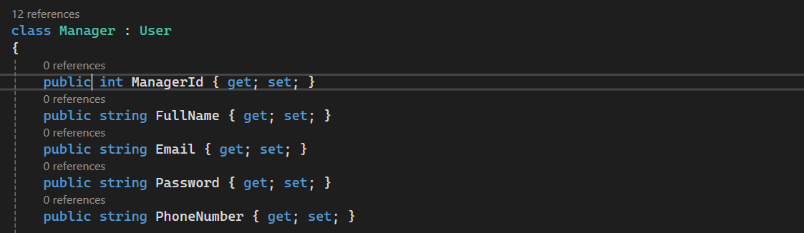

This class is inherited from the User class and includes properties that store the Manager’s personal and login info, accessed and modified with getters and setters. This class provides a foundation for identifying the manager and linking his actions such as (topups,refunds,feedbacks).

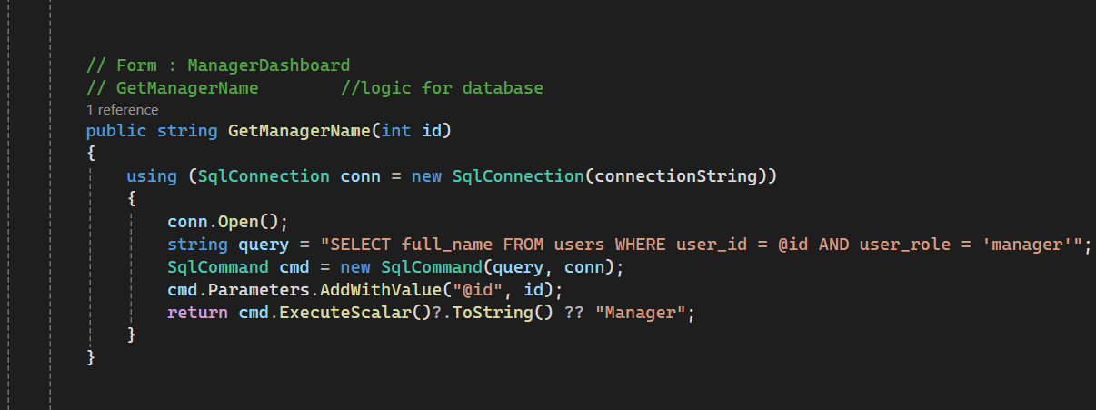

**Method: GetManagerName():**

This method is used to retrieve the full name of the currently logged-in manager using the user_id. It connects to the database, executes a SQL query to fetch the full name from the users table where the role is 'manager'

Then the result will be returned as a string and used.

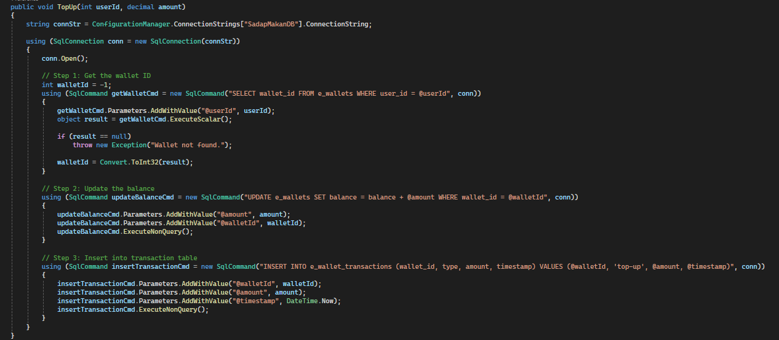

**Method: TopUp ():**

This method main function is to perform a top_up transaction for a selected customer,

It follows a three-step process:

First, it will retrieve the wallet_id for the given user_id,then it will update the wallet balance by adding a specific amount. After that, it will insert a new record into the e_wallet_transacations table to log the top-up event.

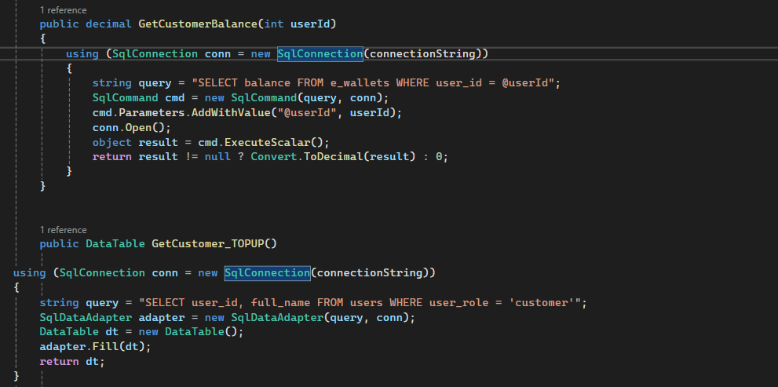

**Method: GetCustomerBalance(int userId):**

This method retrieves the current wallet balance for a customer by their user_id,

It executes SQL query on the e_wallets table to return the balance as decimal. If no record is found it returns 0.

**Method: GetCustomer_TOPUP():**

This method returns a list of users who have the role of a customer. Then it executes a query on the users table to retrieve data; the results will be returned in a DataTable for the Combo box, allowing the manager to select which customer to top up.

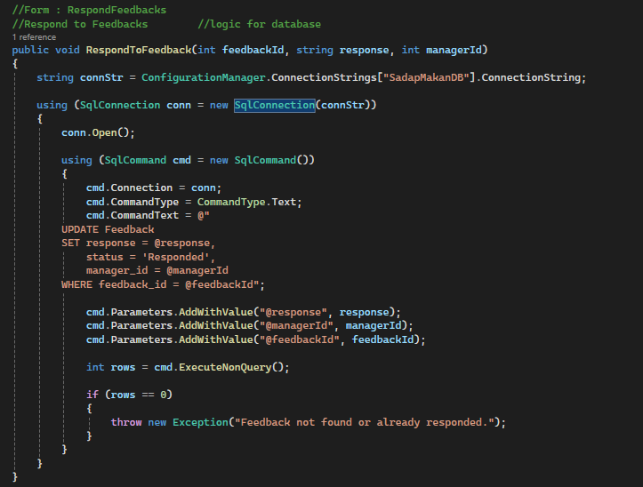

**Method: RespondToFeedback():**

This method is used by the manager to submit a response to selected customer feedback. It updates the response, sets status to ‘responded’, and records the manager_id who responded.

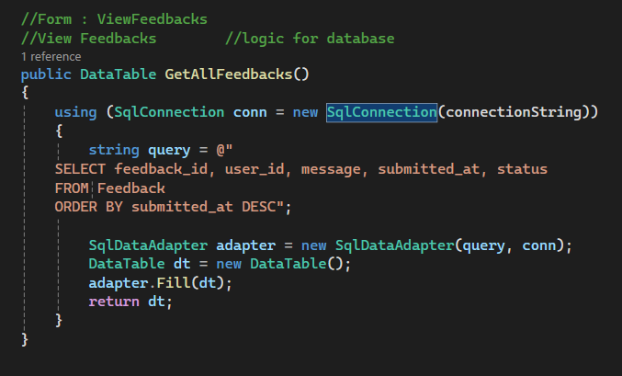

**Method:GetAllFeedbacks():**

This method retrieves all feedback records from the Feedback table, including both new and responded feedback. It orders them by submitted_at in desc order so the most recent would appear first.

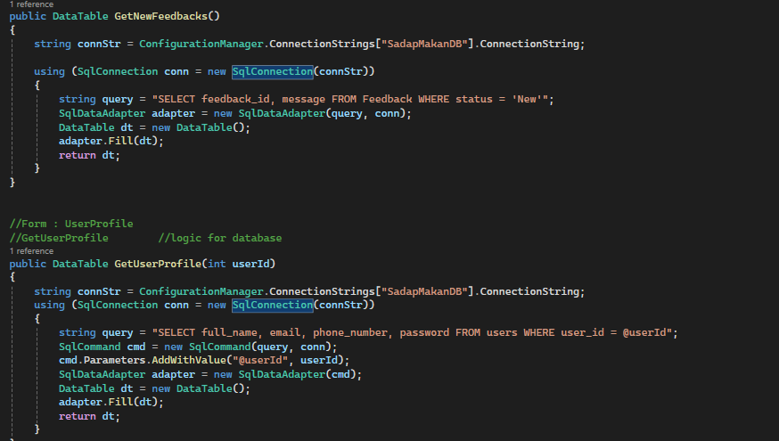

**Method: GetNewFeedbacks():**

This method returns only feedback records that have not yet been responded to. It is used in the RespondToFeedback form to display the Combo box with feedback waiting for manager response.

**Method: GetUserProfile():**

This method retrieves a user’s personal details based on the user_id. It is used to pre-fill the fields in the UpdateProfile form for editing. The query ensures that the correct record is loaded.

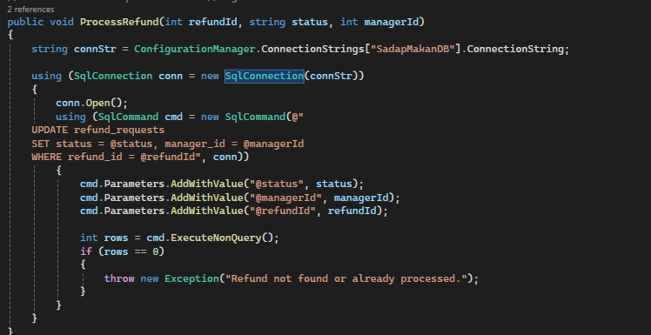

**Method: ProcessRefund():**

This method updates the status of a refund request (approved or rejected)

And records the manager who handled it. Ensuring only valid and pending refunds are modified.

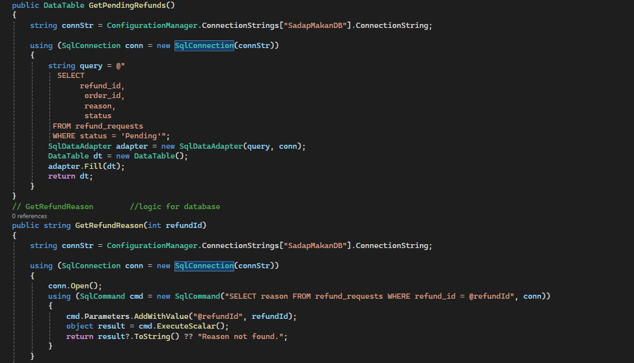

**Method: GetPendingRefunds():**

This method fetches all refund requests that are currently pending. It executes a SQL query to populate the DataGridView in the RedundHandler form.

**Method: GetFundReason():**

This method retrieves the text of the reason submitted by a customer for a specific refund request. It is used to provide the manager with the full context in order to decide whether to approve or reject it.

#### Objects For Manager role:

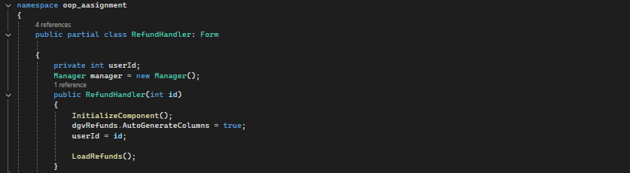

### **1. Manager manager = new Manager();**

Used in almost all manager-related forms to access backend logic.

* Perform top-ups
* Process refunds
* Responds to feedback
* Get cusotmer data
* Update manager profile

**OOP concept:**

Encapsulation: all database operations are wrapped inside the Manager class and accessed through this object.

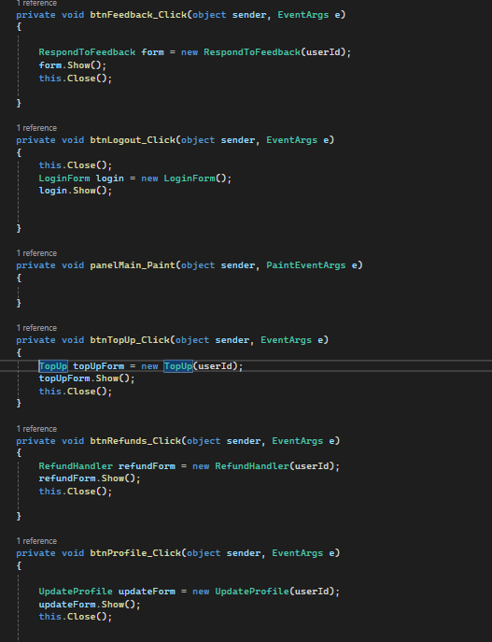

### **2. Form form = new FormName(userId);**

For navigation and passing logged-in manager’s ID to child forms.

* TopUp topUpForm = new TopUp(userId);
* ManagerDashboard dashboard = new ManagerDashboard(userId);
* RespondToFeedback feedbackForm = new RespondToFeedback(userId);

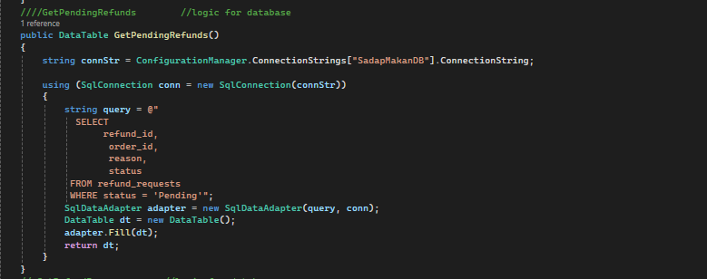

### **3. DataTable dt = manager.GetPendingRefunds();**

Holds refund, feedback, or top-up data retrieved from the database.

Used in:  
All forms that display lists (e.g. RefundHandler, RespondToFeedback.etc)

### **4. SqlCommand, SqlConnection, SqlDataAdapter**

* **Used Inside**: Manager class methods
* **Purpose**:  
   Connect to and query/update the SQL Server database
* **OOP Concepts**:
  + Reusable objects
  + Often created in using blocks for safe resource management

5.3 Chef

### 5.3.1 Class Explanation: The Chef Class

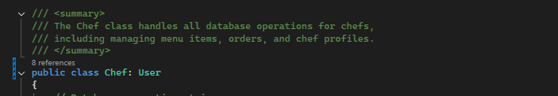

This class is inherited from the User class and includes functions specifically designed for the chef’s role in the system. It allows chefs to manage their profile, add or edit menu items, and view or handle orders. The Chef class builds on the general features of User by extending them with specialized functionalities related to kitchen operations. This class represents a core part of the system where chefs directly interact with the app’s backend logic (menu, orders, profile updates), using OOP principles like inheritance, encapsulation, and abstraction to keep the code clean, modular, and reusable.

### 5.3.2 Methods Explanation:

#### 5.3.2.1 Menu Item Methods Explanation:

##### 5.3.2.1.1 GetMenuItems() Method:

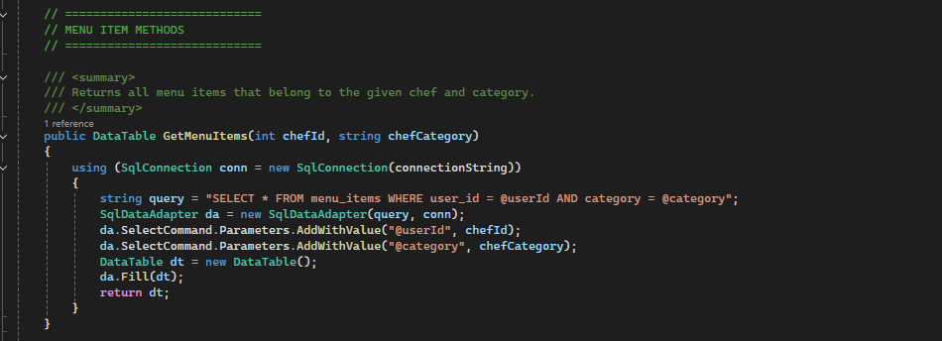

This method is used to **retrieve menu items** from the database that are specifically associated with a particular **chef (chefId)** and **menu category (chefCategory)**. It connects to the SQL database using SqlConnection and uses parameterized queries to securely fetch relevant rows from the menu_items table.

The result is returned in a DataTable, which can then be displayed in the UI (e.g., menu management forms).  
 This method demonstrates **encapsulation**, where the database logic is hidden within the class and **reusability** since the same method can be used across different parts of the application for different chefs and categories.

##### 5.3.2.1.2 AddMenuItem Method:

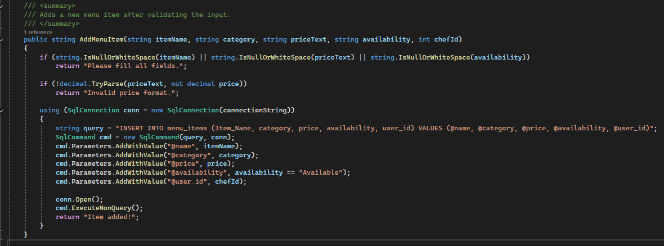

This method allows a chef to **add a new menu item** to the system. It first validates the input fields to ensure none are empty and that the price is in the correct decimal format. Once validated, it opens a connection to the database and inserts the new item into the menu_items table using a **parameterized query**, which helps prevent SQL injection.

The method supports **encapsulation**, as the input validation and database logic are hidden inside the method and not exposed to the rest of the system. It also demonstrates **robust error handling** for user input and ensures the data added is clean and consistent.

##### 5.3.2.1.3 UpdateMenuItem() Method:

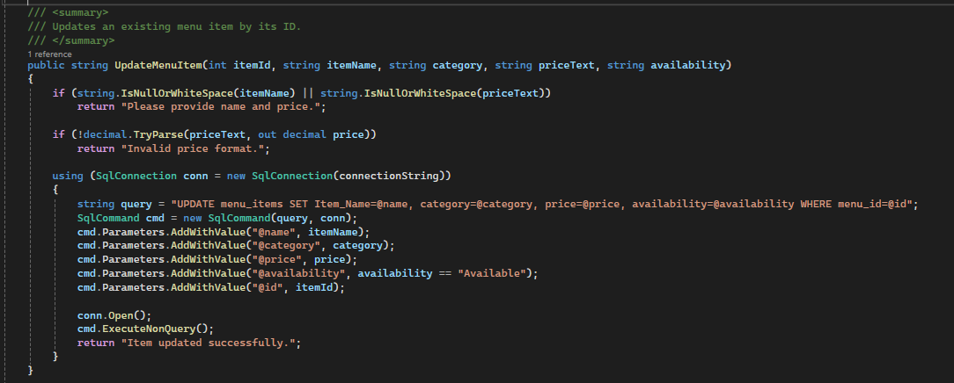

This method allows a chef to **update the details of an existing menu item** by providing its itemId along with updated values for name, category, price, and availability. The method first performs **input validation** to check for empty fields and invalid price formats.

Once validated, the method constructs and executes a parameterized SQL UPDATE query, ensuring **safe and secure modification** of database records. This approach prevents SQL injection and keeps the update operation tightly encapsulated inside the method.

It shows strong **encapsulation and abstraction**, as all the logic is self-contained and reusable, while also demonstrating **modularity** by separating update logic from other responsibilities in the system.

##### 5.3.2.1.4 DeleteMenuItem() Method:

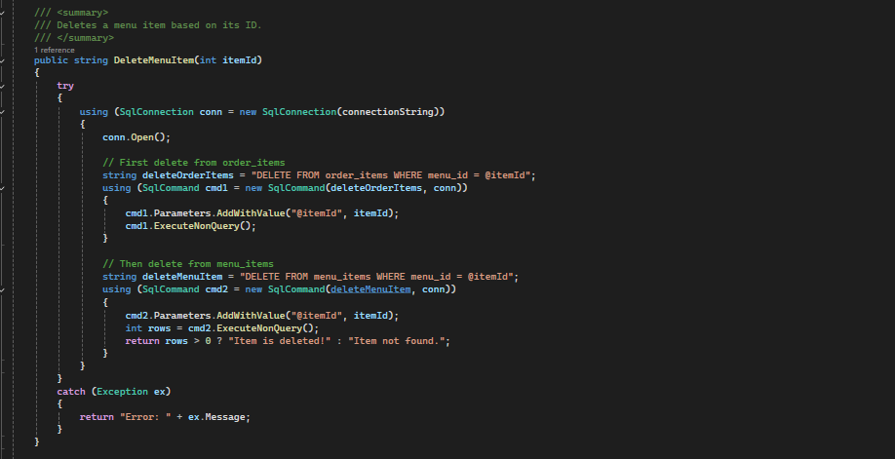

This method enables a chef to safely and permanently delete a specific menu item from the database by providing its unique itemId. Before removing the item itself, the method first deletes any related records in the order_items table to prevent foreign key constraint violations, ensuring referential integrity is maintained. It establishes a secure connection to the SQL database and executes two parameterized DELETE queries — one for the order items and one for the menu item. Using parameterized SQL commands protects the system from SQL injection attacks, enhancing overall security. The logic is encapsulated within a single method, making it reusable, maintainable, and easy to manage. This functionality is essential for allowing chefs to manage and clean up their menu data effectively, especially when a menu item is no longer available or relevant for future orders.

#### 5.3.2.2 Order Methods Explanation:

##### 5.3.2.2.1 GetOrdersByCategory ()Method

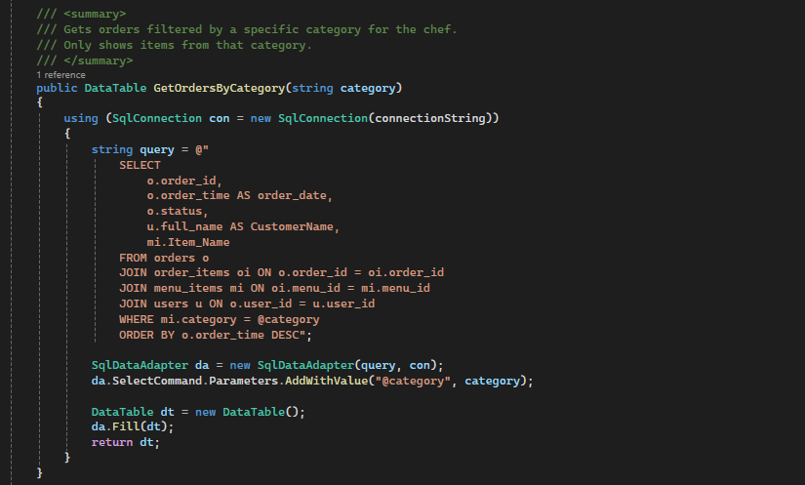

This method allows a chef to **view orders filtered by a specific food category**, such as "Drinks" or "italian Food" ect.... It uses multiple JOIN operations between the orders, order_items, menu_items, and users tables to display complete information: order ID, date, status, customer name, and item name.

The method accepts a category parameter and uses it in a **parameterized query**, ensuring safe filtering and protection from SQL injection. The results are sorted by order time (latest first) and returned in a DataTable for easy UI display.

This method is an excellent example of **abstraction** and **modularity**, providing a focused function that supports order analysis and filtering without exposing the complexity of SQL logic to other parts of the system.

##### 5.3.2.2.3 UpdateOrderStatus() Method

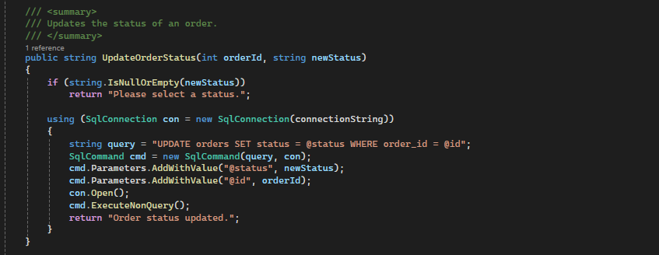

This method is used to **update the status of a specific order**, such as changing it from "Pending" to "Completed". It first checks if the newStatus input is valid, and then runs a **parameterized UPDATE query** to safely modify the status of the order in the database.

By keeping both the database access and input validation inside the method, it ensures **encapsulation** and **security**. The method is clean, reusable, and supports the order management responsibilities of a chef or system admin in the application.

#### 5.3.2.3 Chef Profile Methods Explanation:

##### 5.3.2.3.1 GetCategoryByChefId() Method

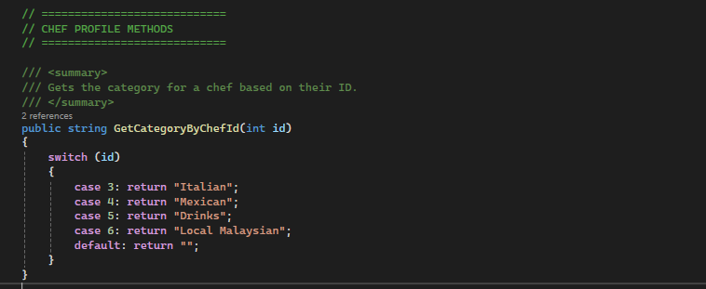

This method is used to **determine the chef's assigned food category** by matching their unique id to a pre-defined category string. It uses a switch statement for quick lookup and returns categories like "Italian", "Mexican", "Drinks", or "Local Malaysian".

This method supports **readability, simplicity, and maintainability**, especially in scenarios where each chef is hardcoded or mapped by ID. It's useful for restricting or customizing what menu items a chef can manage based on their specialization.

While it's not connected to a database, it still follows good design practices with **clear logic encapsulation** and can be easily adapted for future use or migration to dynamic lookup if needed.

##### 5.3.2.3.2 GetChefProfile() Method

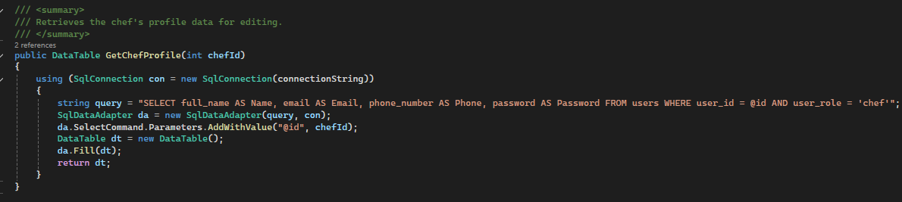

This method retrieves a chef's **personal profile information** from the database using their user_id. The selected fields include full name, email, phone number, and password — all returned in a DataTable so they can be displayed and edited in a user interface.

It uses a **parameterized SQL query** to ensure secure data access, only fetching users with the user_role = 'chef'. This helps enforce role-based access in the system. The logic is cleanly encapsulated within the method, demonstrating good use of **abstraction** and **separation of concerns**, as it keeps UI and data logic separate.

### 5.3.3 Objects Explanation:

#### 5.3.3.1 chefdashboardfrom object

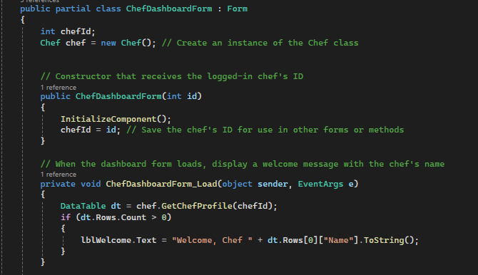

In this system, an object of the Chef class is created using Chef chef = new Chef(); inside the ChefDashboardForm. This object represents a specific chef and is used to access class methods that handle data operations. For example, the object is used in chef.GetChefProfile(chefId) to retrieve the chef’s personal details from the database and display a welcome message on the dashboard. By creating and using this object, the system applies object-oriented programming principles such as **instantiation**, **encapsulation**, and **abstraction**. The form does not need to know how the data is fetched — it simply uses the chef object to get what it needs, keeping the code modular, reusable, and easy to maintain.

#### 5.3.3.2 ManageMenuFrom object

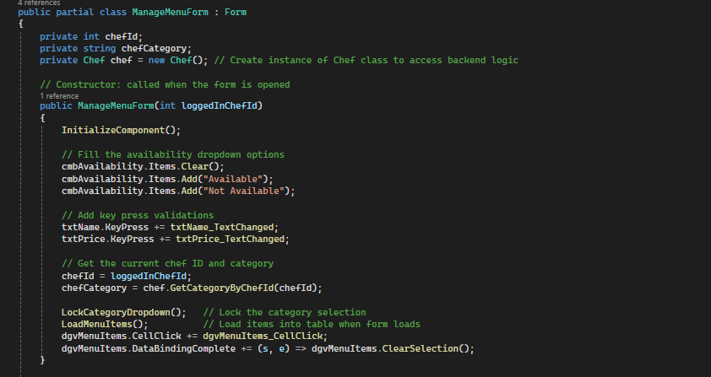

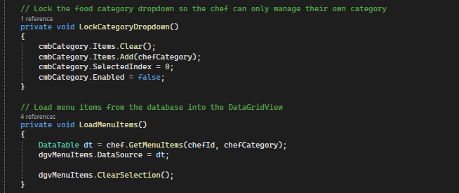

This object, ManageMenuForm, is designed to provide chefs with a secure and role-specific interface for managing their menu items. Upon creation, the object receives the logged-in chef’s ID, retrieves the corresponding food category using a method from the Chef class, and restricts the category selection to ensure the chef can manage only their assigned category. The availability dropdown is initialized with fixed options, and input validation is enforced on both the item name and price fields to prevent invalid data entry. The object then loads all relevant menu items into a DataGridView, which is configured to display only items related to the chef's category. To maintain a clean and user-friendly UI, the object clears any preselected rows both after data binding and during form load. By encapsulating this logic within the form’s constructor and supporting methods, the object ensures consistency, data integrity, and a focused experience tailored to the responsibilities of each individual chef.

#### 5.3.3.3 ViewOrdersFrom object

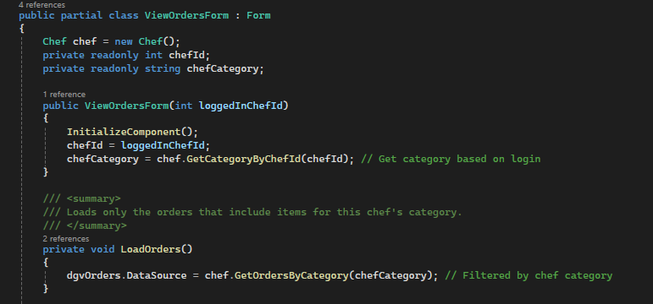

The ViewOrdersForm object is responsible for displaying all customer orders related to a specific chef’s food category. When this object is instantiated, it receives the currently logged-in chef's ID, which is then used to retrieve the associated food category using the Chef class. This ensures that the object operates within the correct context, showing only relevant data. Upon loading, the object calls the LoadOrders() method, which fetches orders filtered by the chef’s category and binds them to a DataGridView for display. To enhance usability, the object clears any default row selections and resets the status dropdown, creating a clean and intuitive interface. Additionally, it assigns an event handler to respond to user interactions with the order grid. Altogether, this object encapsulates role-specific functionality and ensures chefs can view and manage order statuses relevant only to their assigned menu category.

#### 5.3.3.4 UpdateProfileForm object

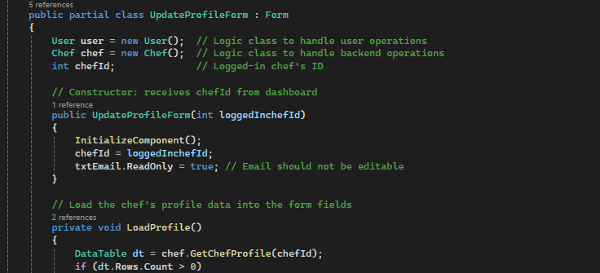

In this form, an object of the Chef class is created using Chef chef = new Chef();. This object is used to retrieve and manage the logged-in chef’s profile information. For example, the method chef.GetChefProfile(chefId) is called to load the chef's data into the form fields. This allows the form to focus purely on the user interface while the Chef class handles all backend operations related to the profile. This use of the chef object demonstrates object-oriented principles such as **instantiation** (creating the object), **encapsulation** (hiding the data-fetching logic inside the method), and **abstraction** (the form uses the method without needing to know how the profile data is retrieved). It helps keep the code modular and organized by separating UI responsibilities from data operations.

5.4 Customer

5.4.1 Customer Class

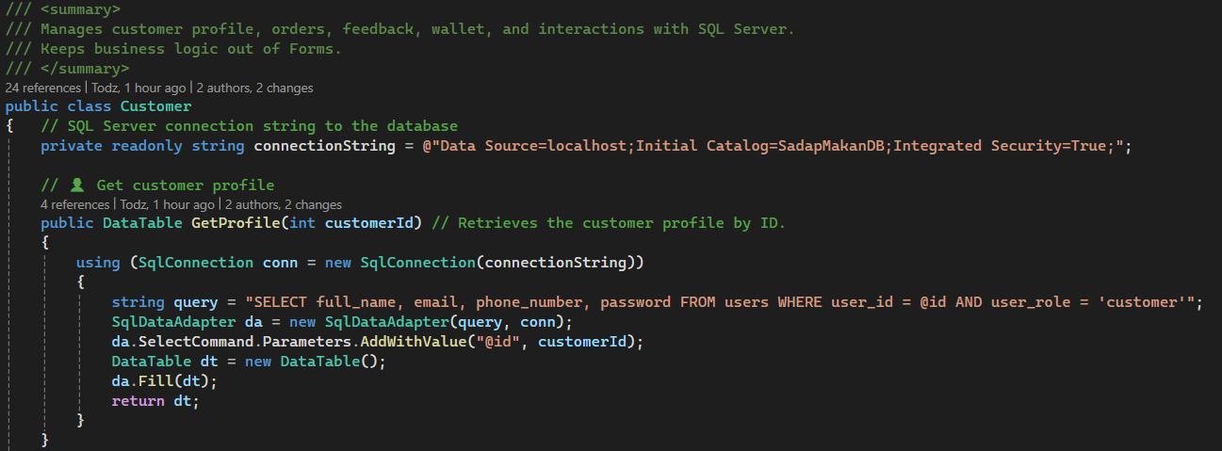

The Login() method is defined inside the User class and is used to authenticate users such as Manager, Chef, and Customer against the records in the users table of the database. It accepts two inputs email and password. It runs a parameterized SQL SELECT query, which allows it to retrieve the user_id and user_role if the user's login credentials are correct and the query finds a match. If successful, it returns a tuple containing the user's ID and the user's role. If it doesn't find a match, it returns the default value indicating that the login is invalid. This method is a core part of the authentication logic and is an example of encapsulation, as it keeps a method for database operations and login validation within the User class for that object's reusable and secure properties throughout the system.

1, Method UpdateProfile

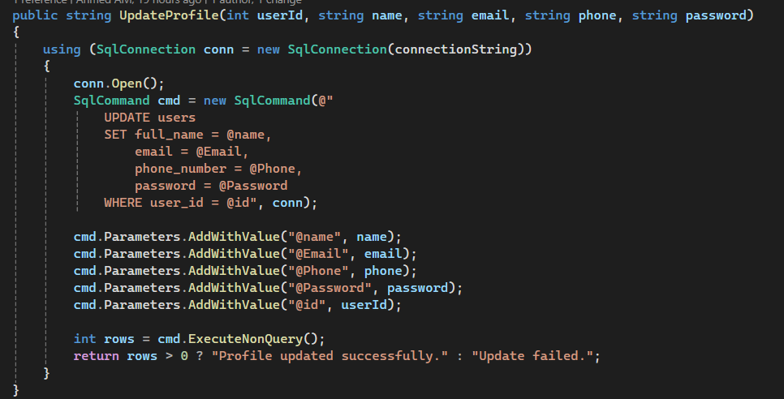

The UpdateProfile() method allows a customer to update five pieces of profile information, full name, email, phone number, and password. The method receives the updated values as parameters, as well as the user's ID (which was obtained when the user registered). The method then executes a parameterized SQL UPDATE query to update the appropriate record in the database. If the update is successful, it returns a success message otherwise, it returns a failure notice. This method demonstrates the concept of encapsulation, as it keeps the database logic within the class and provides a clean interface for other parts of the system, like forms, to update user data without directly interacting with SQL code.

2, Method UpdateSecurityInfo

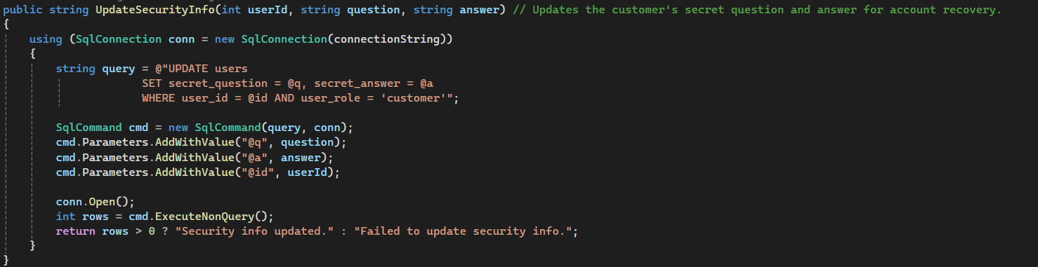

The UpdateSecurityInfo() method allows a customer to set or update their secret question and answer for account recovery purposes. It accepts the user's ID, a security question, and the corresponding answer as inputs, and then executes a parameterized SQL UPDATE query to store this information in the user’s table. If the update is successful, it returns a success message; otherwise, it indicates failure. This method applies to the OOP concept of **encapsulation** by keeping the SQL logic internal to the class, allowing other parts of the system to use it without dealing with the underlying database operations.

3, Method PlaceOrder

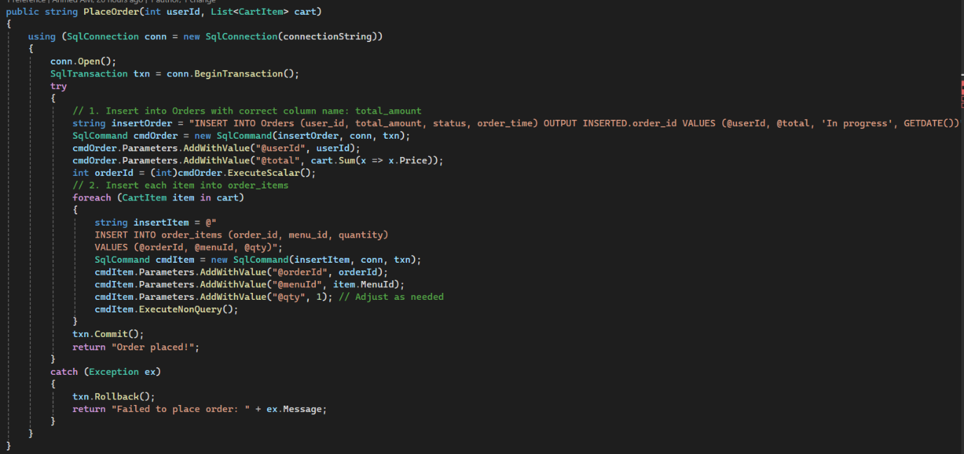

The PlaceOrder() method enables a customer to place an order by taking their user ID and a list of selected CartItem objects. It first inserts the overall order details into the Orders table and then adds each item to the order_items table. This is done within a SQL transaction to ensure all steps are completed successfully. If any part fails, the transaction is rolled back to maintain data integrity. The method returns a successful message if the order is placed correctly. This demonstrates **encapsulation**, as all database operations are handled within the method, keeping the process secure and hidden from the user interface.

4, Method GetOrder

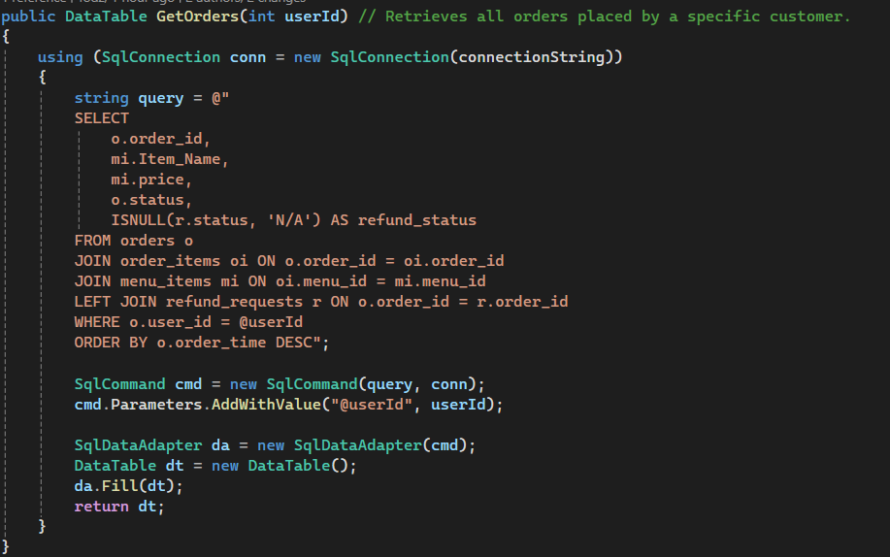

The GetOrders() method retrieves all orders placed by a specific customer using their user ID. It executes a SQL query that joins the orders, order_items, and menu_items tables to return detailed order information such as item name, price, order status, and refund status. The results are sorted by the most recent order time and returned as a DataTable. This method applies **encapsulation** by handling the SQL logic internally, allowing forms to access customer order history with a single method call.

5, Method GetAllMenuItems

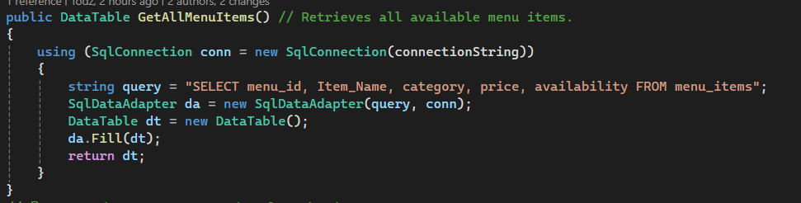

The GetAllMenuItems() method retrieves all available menu items from the database. It executes a simple SQL SELECT query on the menu_items table to return item details such as ID, name, category, price, and availability. The results are stored in a DataTable, which can be easily displayed in the user interface. This method demonstrates encapsulation by hiding database operations and providing a reusable way to access menu data.

6, Method GetDistinctCategories

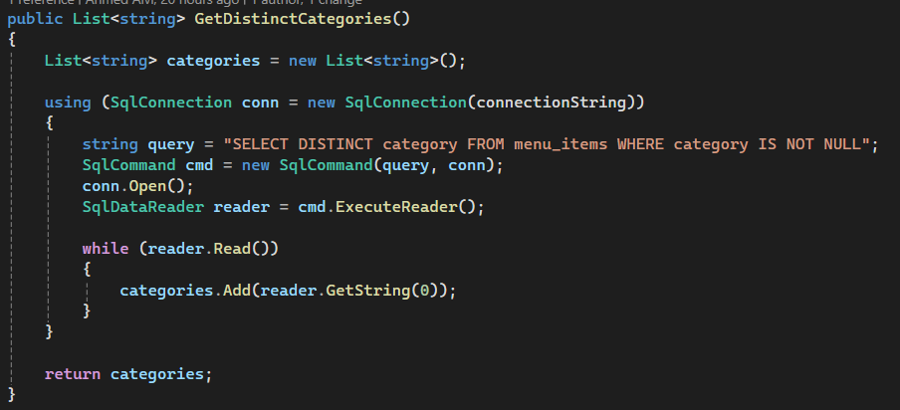

The GetDistinctCategories() method returns a list of unique menu categories from the database. It runs a SELECT DISTINCT query on the menu_items table and adds each result to a list. This method uses **encapsulation** by handling the SQL logic within the class.

7, Method CancelOrder

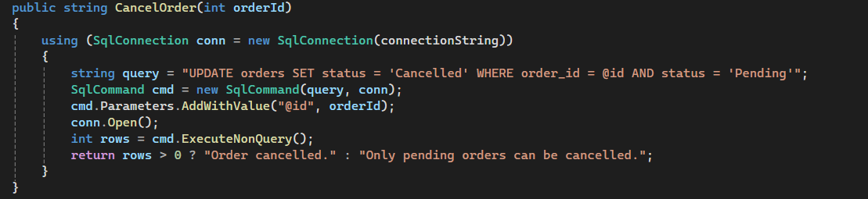

The CancelOrder() method allows a customer to cancel an existing order, but only if its status is still marked as "Pending". It runs an UPDATE query to change the order status to "Cancelled" based on the order ID. The method returns a message indicating whether the cancellation was successful. This demonstrates **encapsulation** by keeping the database update logic inside the method.

8, Method RequestRefund

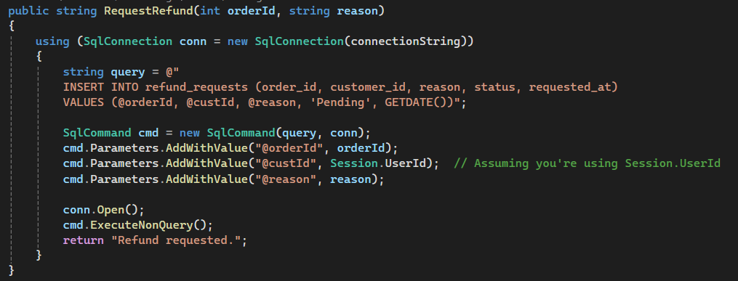

The RequestRefund() method allows a customer to request a refund by inserting the order ID, reason, and user ID into the refund_requests table. It sets the status to "Pending" and records the current date. This method demonstrates **abstraction** by exposing a simple method that handles the refund process, without requiring the caller to manage the underlying SQL operations.

9, Method Submit Feedback

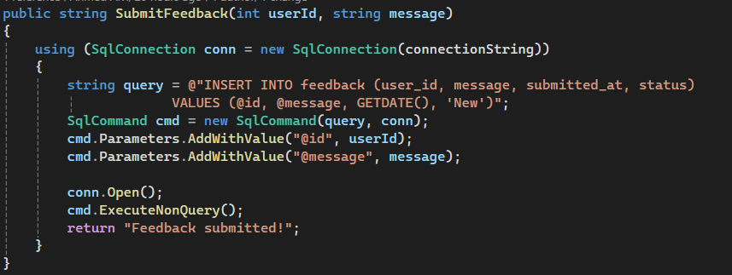

The SubmitFeedback() method allows a customer to submit written feedback to the system. It takes the customer’s userId and a message as input and inserts them into the feedback table, along with the current date and a default status of "New." This method simplifies the feedback process into a single action, demonstrating **abstraction** by hiding the SQL insertion logic from the form or user interface that uses it. It also supports **reusability**, since the same method can be called from any form where customer feedback is collected.

10, Method Get Previous Feedbacks

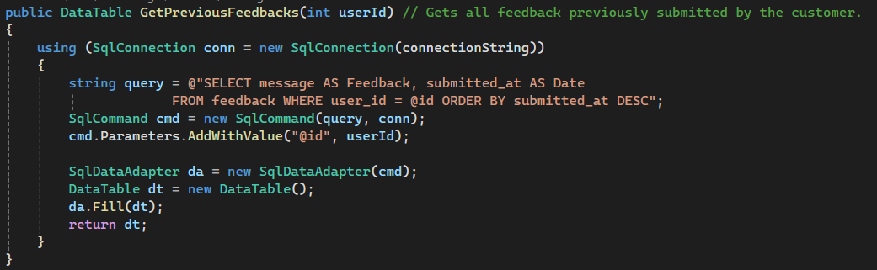

The GetPreviousFeedbacks() method retrieves all feedback entries submitted by a specific customer. It takes the customer’s userId as input and runs a SQL SELECT query to fetch the feedback messages and their submission dates from the feedback table, sorted from newest to oldest. This method demonstrates **abstraction** by offering a simple way to access feedback history, while hiding the SQL details from the calling code. It also supports **reusability**, as it can be used in any form that needs to display a customer's feedback records.

11, Method TopUpEwallet

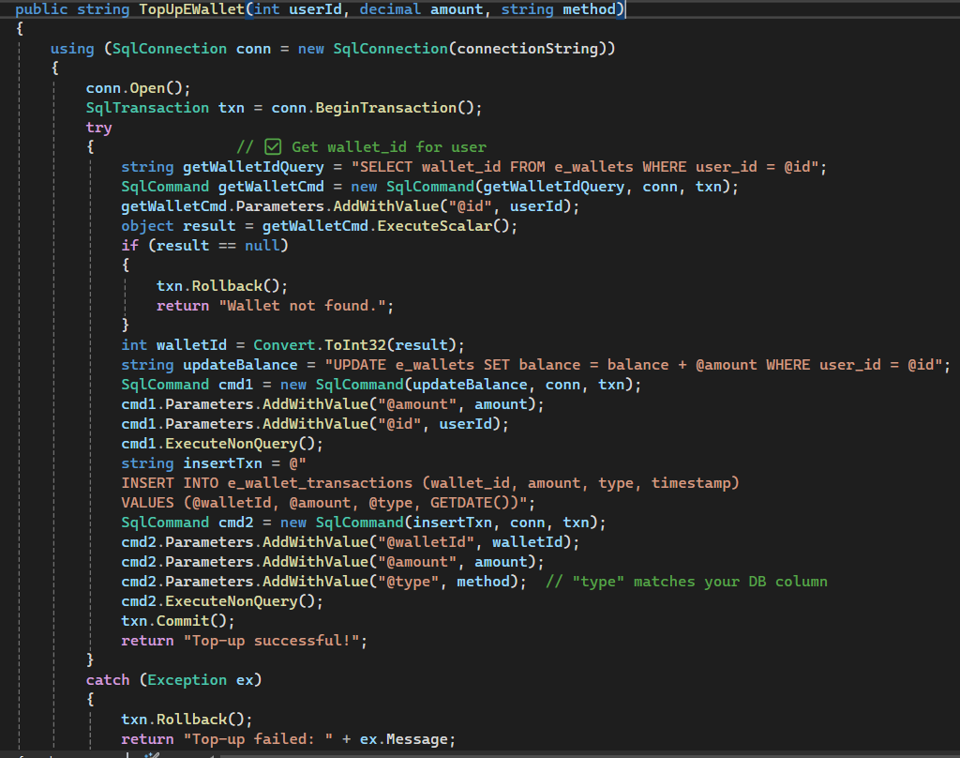

The TopUpEWallet() method allows a customer to add money to their e-wallet by providing their user ID, the amount to top up, and the payment method used. It begins by opening a SQL connection and starting a transaction. The method then retrieves the customer’s wallet ID from the e-wallets table. If the wallet exists, it increases the wallet balance by the given amount and records the transaction in the e-wallet transactions table, including details such as amount, method, and timestamp. All of this is done within a transaction to ensure that either all actions are completed successfully or none, preserving data integrity. If anything fails, the transaction is rolled back. This method applies **abstraction** by wrapping the top-up process into a single method that hides the internal SQL operations, and supports **reusability**, as it can be called from any form where wallet top-ups are handled.

12, Method GetWalletBalance 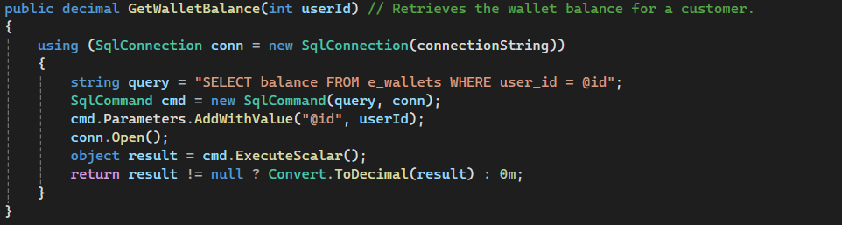

The GetWalletBalance() method retrieves the current balance of a customer’s e-wallet using their user ID. It executes a SQL SELECT query on the e_wallets table to fetch the balance value. If a balance is found, it is returned as a decimal; if not, the method returns 0. This method demonstrates **abstraction** by providing a simple way to check wallet balance without exposing any SQL logic, and supports **reusability**, as it can be used wherever the wallet balance needs to be displayed or calculated.

13, Method GetTransactionHistory

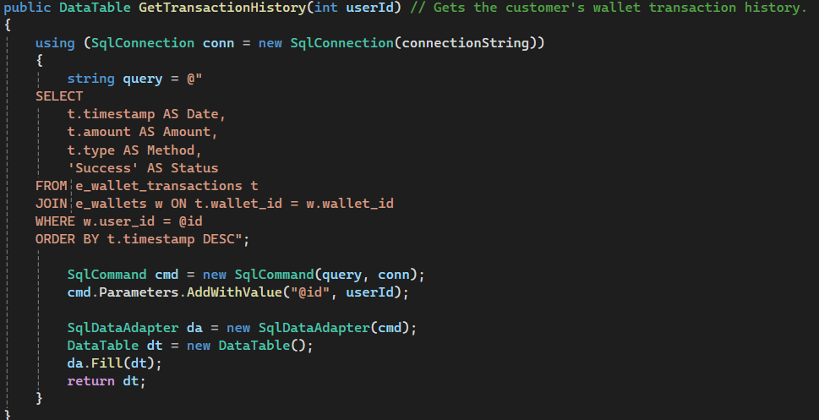

The GetTransactionHistory() method retrieves a customer’s e-wallet transaction history using their user ID. It performs a SQL JOIN between the e_wallet_transactions and e_wallets tables to fetch records that match the user's wallet. The results include the timestamp, amount, payment method, and a fixed "Success" status, sorted by the most recent transaction. This method demonstrates **abstraction**, as it simplifies complex SQL logic into a single reusable call, and supports **reusability** by providing consistent transaction data across multiple parts of the system.

14, Method DeductWalletBalance

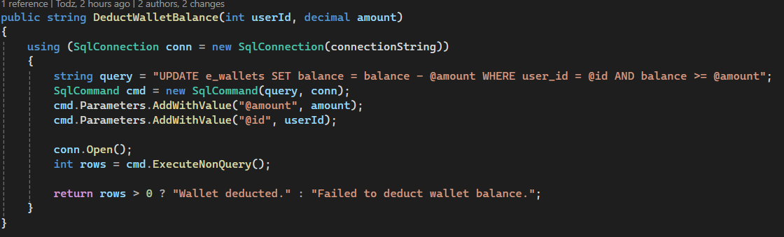

The DeductWalletBalance() method decreases a customer’s wallet balance by a given amount if sufficient funds are available. It uses a SQL UPDATE query to apply the deduction. The method returns a success or failure message based on the result. It demonstrates **abstraction** and **reusability** by simplifying balance deduction into a single method call.

5.4.2 Cart Item Class

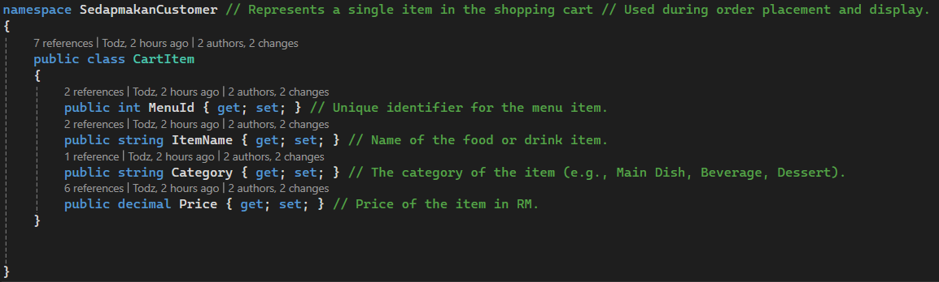

The CartItem class is a simple data model used to represent a single item in a customer's shopping cart. It contains properties such as MenuId, ItemName, Category, and Price, which store the essential details of each selected menu item. This class is typically used during order placement, where a list of CartItem objects is passed to the PlaceOrder() method.

This class demonstrates **encapsulation**, as it neatly packs related item data into one reusable structure. It also supports **object usage**, since objects of CartItem are created and added to a list as the customer selects items from the menu.

5.4.3 Session Class

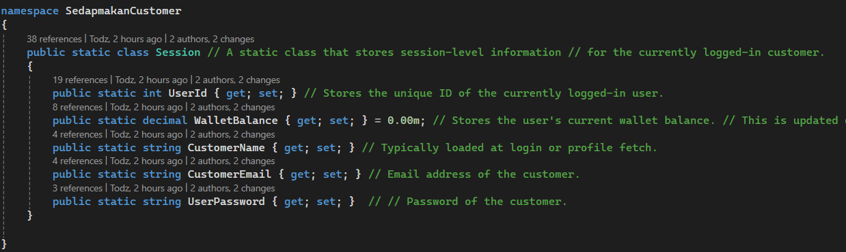

The Session class is a static class used to store session-level data for the currently logged-in customer. It holds key properties such as UserId, CustomerName, CustomerEmail, WalletBalance, and UserPassword. These values are typically set after a successful login and are accessed throughout the system to personalize the user experience and track user-specific actions like feedback, orders, and wallet transactions.

This class demonstrates the concept of **abstraction**, as it provides a centralized way to access user data without needing to retrieve it repeatedly from the database. Since it is declared as static, it ensures that the session data is globally accessible without requiring object instantiation, making it both efficient and consistent across the application.

5.4.4 Objects

1,

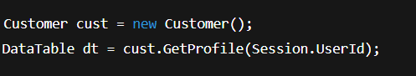

**Used In:** CustomerDashboardForm_Load  
**Purpose:** To fetch the full name of the logged-in customer using the session's UserId, and display it as a personalized welcome message on the dashboard.

**OOP Concept:**

* **Object instantiation:** Creates an object of the Customer class.
* **Encapsulation:** Hides SQL logic inside GetProfile().

2,

 **Used In:** btnConfirmTopUp_Click (FormEWallet)  
**Purpose:** To add funds to the user's e-wallet using the specified amount and method. This is triggered after validating the top-up form inputs.

**OOP Concept:**

* **Object usage:** Uses the cust object to call TopUpEWallet().
* **Abstraction:** The form doesn't handle SQL logic—it just gets the result from the method.

3,



**Used In:** btnConfirmTopUp_Click  
**Purpose:** After a successful top-up, this call retrieves the updated wallet balance to refresh the balance label and session value.

**OOP Concept:**

* **Encapsulation:** The SQL to fetch the balance is handled inside GetWalletBalance().
* **Reusability:** Can be called anytime wallet info is needed.

4,

 **Used In:** FormEWallet_Load and after top-up  
**Purpose:** To fetch and display the user's wallet transaction history in a grid when the e-wallet form is opened or refreshed.

**OOP Concept:**

* **Abstraction:** The form doesn’t handle database details.
* **Object reuse:** Same cust object is used for multiple method calls.

5,

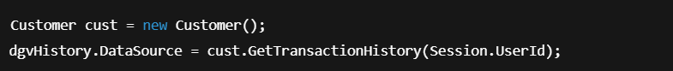

**Used In:** btnConfirmTopUp_Click (after a successful top-up)

**Purpose:**  
After confirming a wallet top-up, this object is used to reload the user's latest transaction history and update the DataGridView (dgvHistory) with new data.

**OOP Concept:**

* **Object instantiation:** Reuses the Customer object created earlier in the method.
* **Abstraction:** The form only needs the result—it doesn’t handle how the data is fetched.
* **Encapsulation:** The logic to query the database and return a DataTable is fully contained within the method.

CHAPTER 6: TEST PLAN & TEST CASES

|  |  |  |  |  |  |
| --- | --- | --- | --- | --- | --- |
| **Test Case** | **Function Name** | **Test Objective** | **Expected Result** | **Actual Result** | **Remarks** |
| 1 | Login | Log in with valid email and password | Redirected to correct dashboard based on role | Success and error messages are shown appropriately based on credentials | None |
| 2 | ProcessRefund | Test that manager can approve a refund request | Refund status changes to "Approved" | Refund status changes to “Approved” as expected | Confirmation message shown |
| 3 | Top-Up E-Wallet | Verify manager can top up customer’s e-wallet | Customer’s balance is increased, transaction logged | E-wallet balance updated, and transaction logged correctly | Displayed balance matches expected total |
| 4 | UpdateOrderStatus | Ensure chef can update order status from "In Progress" to "Completed" | Order status updates correctly in database | Chef updated status to “Completed” and order reflected in system | System log confirms the status update |
| 5 | Submit Feedback (Customer) | Verify that customer can submit feedback | New feedback is stored in DB with status “New” | Feedback submitted and stored with “New” status in database | Time and customer ID recorded properly |
| 6 | Update Profile (Manager) | Verify that manager can successfully update their profile info | Updated name/email/phone/password saved in database | Profile info updated and reflected on next login | None |
| 7 | Customer Registration | Verify that a new customer can register | Customer account is created and login is enabled | Account created, redirected to login screen | Validation passed for all fields |
| 8 | Forgot Password | Check if password reset works for valid email | Reset link or new password is issued | Reset email sent, new password accepted | None |
| 9 | Browse Menu (Customer) | Ensure customer can view all menu categories | All available items are displayed by category | All menu categories and items displayed without delay | Menu grouped correctly by category |
| 10 | Add to Cart | Customer adds item to cart | Item appears in cart with correct quantity and price | Item added with correct quantity and total calculated | None |
| 11 | Place Order | Customer places an order | Order is recorded and sent to kitchen queue | Order placed successfully, visible to chef dashboard | Order ID recorded in database |
| 12 | View Order (Customer) | Customer views their active and completed orders | Correct status and order history is displayed | Customer order history and statuses shown correctly | Sort function works as expected |
| 13 | View Orders (Chef) | Chef sees all orders assigned to their category | Orders show with accurate details and real-time updates | Chef can view all assigned orders by dish category | Orders refresh in real time |
| 14 | Respond to Feedback | Manager replies to customer feedback | Response saved and visible to customer | Manager response saved and visible to customer | Timestamp and staff ID saved |
| 15 | View Sales Report | Admin generates report of total sales | Summary and totals generated correctly | Report shows total sales by date and category | Export option functional |
| 16 | Edit Menu (Chef) | Chef updates dish name/price | Changes reflected in customer-facing menu | Dish updated, reflected immediately in menu view | Updated price and availability saved |
| 17 | Profile Update (Customer) | Customer updates their name or password | Database updated and reflected on next login | Changes reflected immediately after saving | Success message shown |
| 18 | Session Management | Check if session is maintained across forms | User stays logged in while navigating system | User remained logged in when moving between forms | Session expires correctly after timeout |
| 19 | View Feedback (Admin) | Admin views all feedback | Feedback appears in full with correct timestamps | Admin can view feedback with timestamp and customer info | Filter by date and category works |
| 20 | Help Access | Verify Help section is accessible | Help instructions open without errors | Help content displayed without issues | Text formatting and images appear correctly |
| 21 | Login (Negative) | Try logging in with incorrect password | Show “Invalid login credentials” message | “Invalid credentials” message shown for wrong password | Prevented access as expected |
| 22 | Sign Up (Negative) | Submit form with empty required fields | Show validation errors; account not created | Validation message shown for empty fields | Red borders highlight missing fields |
| 23 | Top-Up E-Wallet (Negative) | Enter a negative top-up amount | Show error; transaction rejected | Error message shown, no transaction recorded | Balance unchanged, validation works |
| 24 | Place Order (Negative) | Try to place order with an empty cart | Show error; order not processed | Order blocked with alert about empty cart | Alert is clear and properly styled |
| 25 | Submit Feedback (Negative) | Submit feedback without any message content | Validation error shown; feedback not submitted | Form submission blocked, message required | Validation handled at both UI and DB level |

CONCLUSION

The SedapMakan Management System successfully fulfils the core objectives of providing an efficient and user-friendly platform for managing restaurant operations, food ordering, and customer interactions. By incorporating object-oriented programming principles such as classes, methods, and objects, the system ensures modularity and maintainability. The integration of a graphical user interface (GUI) with a structured database allows users to interact with the system intuitively while maintaining data consistency and accuracy. (BasuMallick, 2022)

Each user role—System Admin, Manager, Chef, and Customer—has been thoughtfully implemented with role-specific functionalities that reflect real-world operational needs. The admin can manage users and generate insightful reports; the manager can handle customer services such as feedback and refunds; chefs can manage menu items and order progress; while customers enjoy a seamless food ordering and e-wallet experience.

Among the strengths of the system are its clear user access control, smooth user navigation based on login roles, and its modular design that allows future scalability. However, there are also areas for improvement. For example, the system could benefit from additional features such as real-time order notifications, mobile responsiveness, or integration with third-party payment gateways. (Gupta, 2023)

In future enhancements, the system could be upgraded to support a web or mobile-based platform, allow multi-language support for international customers, and include analytics for business insights. Overall, the development of this system has been a valuable learning experience in applying object-oriented programming in a real-world scenario, and it lays a solid foundation for further development and innovation.

REFERENCES

altkom Software. (2023, May 29). *Use Case Diagrams: An Introduction*. Retrieved from altkom Software: https://www.altkomsoftware.com/blog/use-case-diagrams-an-introduction/

BasuMallick, C. (2022, September 13). *What Is OOP (Object Oriented Programming)? Meaning, Concepts, and Benefits*. Retrieved from spiceworks: https://www.spiceworks.com/tech/devops/articles/object-oriented-programming/

GeeksforGeeks. (2024, December 16). *C# Tutorial*. Retrieved from GeeksforGeeks: https://www.geeksforgeeks.org/c-sharp/csharp-programming-language/

GeeksforGeeks. (2025, January 11). *C# Methods*. Retrieved from GeeksforGeeks: https://www.geeksforgeeks.org/c-sharp/c-sharp-methods/

Gupta, N. (2023, May 26). *What is Class Diagram ? Basics*. Retrieved from Medium: https://medium.com/@ngneha090/what-is-class-diagram-basics-cd3db4ed05df

Sander Rossel. (2014, November 2). *Using C# to connect to and query from a SQL database*. Retrieved from Sander Rossel: https://sanderrossel.com/using-c-to-connect-to-and-query-from-a-sql-database/

Singh, A. P. (2024, June 9). *UML Class Diagram Explained with Examples*. Retrieved from AlgoMaster Newsletter: https://blog.algomaster.io/p/uml-class-diagram-explained-with-examples

*Use case diagramming best practices and examples*. (2024, June 18). Retrieved from Justinmind: https://www.justinmind.com/blog/use-case-diagramming-examples/

WORKLOAD MATRIX

|  |  |  |  |
| --- | --- | --- | --- |
| **No.** | **Assigned Task & Brief Description** | **Assigned Member Name** | **Completion Status / Comment** |
| 1. | System Admin Role  -Class Diagram  -Use Case Diagram  -References -Workload Matrix  -Merging of C# Code  -Database Creation | AHMED MIRAHUSAIN ALVI TP084807 | ✓ |
| 2. | Manager Role  -Use Case Diagram  -Class Diagram  -Test Case  -User Class | BADR MAHDI MUBARAK AL-AMRI TP083084 | ✓ |
| 3. | Chef Role  -LoginForm  -SignUpForm  -ForgetPasswordForm  -HelpForm  - Introduction  - Conclusion  - Test Case  - Use Case Diagram  - Database Creation  - User Class | MOHAMED ABA SAID TP082376 | ✓ |
| 4. | Customer Role | AHAMAD MUHAMAD MUSTHAFA TP085194 | ✓ |